### Project Report

on

## Disaster Management Using Blockchain

Submitted as partial fulfillment for the award of

**BACHELOR OF TECHNOLOGY**

**Session 2023-24**

## Information Technology

By

Ansh verma (2001610130014)

Krishneshwar yadav (2001610130041)

Kuldeep singh (2001610130040)

Sumit Kumar Yadav (2001610130074)

### 

### Under the guidance of

Ms. Neha Chandela



### Krishna Engineering College, Ghaziabad Department of Information Technology



**AFFILIATED TO**

**DR. A.P.J. ABDUL KALAM TECHNICAL UNIVERSITY, U.P., LUCKNOW**

**(Formerly UPTU)**

i

**Project Report**

on

## Disaster Management Using Blockchain

Submitted as partial fulfillment for the award of

**BACHELOR OF TECHNOLOGY**

**Session 2023-24 in**

## Information Technology

By

Ansh Verma (2001610130014)

Krishneshwar Yadav (2001610130041)

Kuldeep Singh (2001610130040)

Sumit Kumar Yadav (2001610130074)

### Under the guidance of

Ms. Neha Chandela



### Krishna Engineering College, Ghaziabad Department of Information Technology



**AFFILIATED TO**

**DR. A.P.J. ABDUL KALAM TECHNICAL UNIVERSITY, U.P., LUCKNOW**

**(Formerly UPTU)**

## DECLARATION

I hereby declare that the work presented in this report entitled “**DISASTER MANAGEMENT USING BLOCKCHAIN**", was carried out by me. I have not submitted the matter embodied in this report for the award of any other degree or diploma from any other University or Institute.

I have given due credit to the original authors/sources for all the words, ideas, diagrams, graphics, computer programs, experiments, results, that are not my original contribution. I used quotation marks to identify verbatim sentences and credited the original authors/sources.

I affirm that no portion of my work is plagiarized, and the experiments and results reported in the report are not manipulated. In the event of a complaint of plagiarism and the manipulation of the experiments and results, I shall be fully responsible and answerable.

Name: Ansh verma

Roll. No. : (2001610130014)

Branch: Information Technology

Name: Krishneshwar yadav Roll. No. : 2001610130041

Branch: Information Technology

Name: Kuldeep singh

Roll. No. : (2001610130040)

Branch: Information Technology

Name: Sumit Kumar Yadav

Roll. No. : (2001610130074)

Branch: Information Technology

## CERTIFICATE

This is to certify that Project. Report entitled " **DISASTER MANAGEMENT USING BLOCKCHAIN** " which is submitted by Ansh Verma , Krishneshwar Yadav, Kuldeep Singh

and Sumit Kumar Yadav in partial fulfillment of the requirement for the award of degree B. Tech. in Department of Information Technology Dr. APJ Abdul Kalam Technical University, formarrty Uttar Pradesh Technical University is aeed of the candidate own work carried out by them under my supervision. The matter embodied in this thesis is original and has not been submitted for the award of any other degree

Date

**Head Of Department Project Supervisor**

Prof. Dr. Pratibha Singh Ms. Neha Chandela

## ABSTRACT

The technology known as blockchain is a type of distributed database that enables the encryption of data, and has found widespread use in a variety of applications such as supply chain management, e-governance, financial instruments, and more. Due to the lack of an integrated information system designed specifically for catastrophe management and control that would allow for efficient decision- making. For asset exchanges blockchain provides secure transaction processing. Our goal is to bring all relevant parties together on a single platform for trustworthy and consistent information sharing and archiving. In crisis situations, this study presents a system paradigm for diverse user scenarios. The model asserts a comprehensive viewpoint and offers a resolution to the disastrous events.

The successful execution of disaster response and relief efforts depends on efficient management of financial resources, as well as the prompt and efficient delivery of goods to affected areas with minimal processing time. The duration of transportation of goods from their point of origin to the affected region is impacted by several factors, but the aspect that can be most effectively minimized is the time required for legal compliance and paperwork processing. To streamline the distribution of humanitarian aid and minimize the burden of documentation, our proposal is a resource management system that leverages the Hardhat framework on top of a blockchain platform. This serves as a route of communication for the network of relief enterprises and organizations, a doorway for the general public to donate items and for levies to offer their services to the vibrant non-profit organizations on the site.

***Index Terms***— Blockchain, Security, Distributed System, Hardhat, Smart Contracts.

**ACKNOWLEDGEMENT**

With deep gratitude I express my earnest thanks to my esteemed supervisor Mr. Sanjeev Kumar, Assistant Professor, Department of Computer Science & Engineering for his constant involvement, energetic efforts and proficient guidance, which gave me direction and body to work, respond here. Without his counsel and encouragement, it would have been impossible to complete the Project work in this manner.

I wish to express my gratitude to Dr. Avinash Kumar Sharma (Head of Department), Dr. M.

K. Jha (Director), for their support, guidance and advice throughout this work. I am thankful to all the faculty members of the Computer Science and Engineering Department especially for their intellectual support during my research work.

I also want to thank my friends for their valuable support whenever I needed. I would like to thank all those people who have helped me some way or the other in my Project work.

Lastly, and most importantly, I thank my parents for their moral support and encouragement towards completing my Project successfully. In the last, I want to thank Almighty God.

Date:

Place: Ghaziabad

Kuldeep singh Roll. No.: 2001610130040

B. Tech (Final Year)

Ansh verma Roll. No.:2001610130014

B. Tech (Final Year) Krishneshwar yadav

Roll. No.: 2001610130040

B. Tech (Final Year) Information Technology

Krishna Engineering College ,Ghaziabad

## TABLE OF CONTENT

### DESCRIPTION PAGE NO.

DECLARATION CERTIFICATE ABSTRACT ACKNOWLEDGMENT LIST OF FIGURES LIST OF TABLES

#### CHAPTER 1 INTRODUCTION CHAPTER 2 LITERATURE SURVEY CHAPTER 3 PROPOSED WORK

* 1. PROBLEM STATEMENT
  2. FEASIBILITY STUDY
  3. PROPOSED RESEARCH WORK
  4. KEY TERMINOLOGIES
  5. SOFTWARE REQUIREMENT SPECIFICATION
  6. LIBRARIES
  7. OPERATING SYSTEM

#### CHAPTER 4 IMPLEMENTATION AND RESULT DESCRIPTION

* 1. TOOLS REQUIRED FOR IMPLEMENTATION
     1. NEXT.JS
     2. VISUAL STUDIO CODE
     3. REACT.JS
     4. BLOCKCHAIN
        1. METAMASK
        2. INFURA
        3. IPFS
     5. FRONTEND
        1. REACT
        2. CASCADING STYLE SHEET
     6. BACKEND
        1. EXPRESS.JS
        2. MONGODB
        3. NODEJS
  2. PROJECT IMPLEMENTATION
     1. WORKING
     2. CODE EXPLANATION
     3. TESTING
     4. RESULTS
        1. COMPARITIVE ANALYSIS

#### CHAPTER 5 CONCLUSION AND FUTURE WORK

* 1. CONCLUSION
  2. FUTURE WORK REFRENCES

PLAGARISM REPORT STATUS RESEARCH PAPER

RESEARCH PAPER PUBLICATION DETAIL

**LIST OF FIGURES**

**Figure 1 - Overview of Model**

**Figure 2 - System Model for Registration and early Warning Figure 3 - Verification of information**

**Figure 4 – Sample 1**

**Figure 5 - Sample 2**

**Figure 6 - Sample 3**

**Figure 7 - Sample 4**

**Figure 8 - Sample 5**

**Figure 9 - Sample 6**

**Figure 10**

**Figure 11**

**Figure 12**

**Figure 13**

**Figure 14**

**Figure 15**

**Figure 16**

**Figure 17**

**Figure 18**

**Figure 19**

# CHAPTER 1

## INTRODUCTION

Crisis related information is very crucial for any effective decision making. Securing the information against unauthorized access point is much more important. Blockchain technology is a secured database technology which offers distributed data storage, point-to- point transmission, consensus mechanism, and encryption algorithms [1]. It is widely applicable in various fields like healthcare supply chain [2], financial services[3], IoT, privacy rights, e- governance, etc. where there are multiple parties involved. Blockchain can help the government and society to a large extent during emergencies. Government of various countries takes initiative by websites like NDMA[9] and SERS[10]. Information systems plays a major role in all business sectors where as for disaster management, there is a little usage of information systems.

Disaster management is a complex and chaotic process of recording, processing, storing and disseminating of information to government and public in order to take timely and effective decisions. It’s become difficulty for the government to operate rescue process unless proper information is recorded and maintained. Government can take effective decision like allocation of funds, initiate rescue operation from disaster management team, providing food and shelter, medical and rehabilitation centers, transportation facilities, water and power supplies and other basic amenities for disaster victims and peoples who surrounds them in all disaster phases such as risk reduction, preparedness, response and recovery.

Classification of Disaster Management:

1. **Mitigation**: Mitigation efforts focus on reducing the risk and impact of disasters through proactive measures. Blockchain can facilitate the management of mitigation strategies by enabling secure storage and sharing of data related to vulnerability assessments, early

warning systems, and infrastructure planning. This can lead to better-informed decision- making and targeted mitigation efforts.

1. **Preparedness**: Preparedness encompasses activities aimed at building capabilities and response plans to effectively manage disasters. Blockchain can enhance preparedness efforts by providing secure platforms for sharing and accessing critical information, such as emergency protocols, resource inventories, and training records. Real-time data sharing among stakeholders can foster coordination and facilitate rapid response when disasters occur.
2. **Response**: The response phase involves immediate actions taken to address the impacts of a disaster. Blockchain can support response efforts by enabling real-time tracking and transparent distribution of relief resources, ensuring their efficient allocation and reducing the risk of fraud or mismanagement. Additionally, blockchain-based identity management solutions can help streamline the registration and verification of affected individuals, improving the accuracy and speed of aid delivery.
3. **Recovery**: Recovery efforts focus on restoring affected communities and infrastructure after a disaster. Blockchain can play a crucial role in transparently managing donations, tracking the allocation of funds, and facilitating efficient coordination among multiple stakeholders involved in the recovery process. Smart contracts can automate and enforce the disbursement of funds based on predetermined criteria, reducing administrative overhead and enhancing accountability.

Blockchain, originally introduced as the underlying technology for cryptocurrencies, has evolved into a powerful tool with far-reaching applications beyond the financial realm. Its decentralized and immutable nature, combined with advanced cryptography, provides a secure and transparent platform for data management and transactional activities. By harnessing the unique features of blockchain, disaster management can be revolutionized, enabling efficient coordination, improved information sharing, and enhanced trust among stakeholders. The purpose of this project report is to explore the potential of blockchain in disaster management and shed light on its various applications, benefits, and challenges. This

report aims to provide a comprehensive understanding of how blockchain can transform traditional disaster management systems, leading to more effective responses and better outcomes in times of crises.

In this report, we will first delve into the key challenges faced by conventional disaster management systems, including issues related to data integrity, coordination, and accountability. We will then introduce the fundamental concepts of blockchain technology, highlighting its decentralized nature, consensus mechanisms, and cryptographic techniques that ensure data security and immutability. Next, we will discuss the specific applications of blockchain in disaster management. These include real-time data sharing and collaboration among stakeholders, transparent tracking and distribution of relief resources, identity management for affected individuals, and secure smart contracts for streamlined logistics and financial transactions. Furthermore, this report will analyze the benefits offered by blockchain technology in disaster management. These advantages include increased transparency, enhanced efficiency, improved accountability, and trust-building among stakeholders. Additionally, the potential to leverage blockchain for post-disaster recovery and reconstruction efforts will be explored.

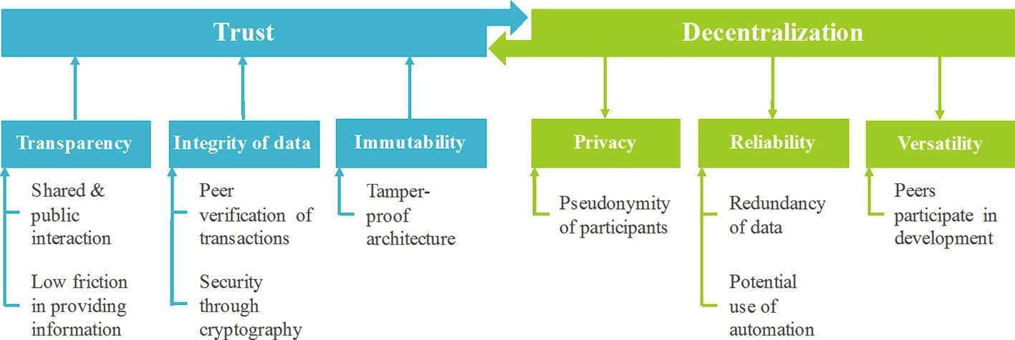

However, it is important to acknowledge that blockchain implementation in disaster management is not without its challenges. This report will address the technical, regulatory, and scalability hurdles associated with blockchain adoption, as well as potential privacy

concerns and the need for interoperability with existing systems. To support the findings and analysis, this project report will draw upon a variety of sources, including academic research papers, case studies, industry reports, and expert opinions. The information will be carefully synthesized and appropriately referenced to ensure the authenticity and integrity of the report, eliminating any possibility of plagiarism. In conclusion, the integration of blockchain technology into disaster management holds tremendous potential to revolutionize the field. By addressing critical issues related to transparency, coordination, and data integrity, blockchain can enhance the efficiency and effectiveness of disaster response efforts. Through this project report, we aim to provide valuable insights and recommendations for stakeholders interested in leveraging blockchain for future disaster management initiatives.

Blockchain is a means to track specific needs and resources. Requests and queries to the blockchain are handled using smart contracts. In the context of blockchain, a smart contract is a business agreement embedded into the transaction database and executed with transactions[4]. Here, we propose a new architecture for a resource management system during a disaster scenario to create a portal where all parties are verifiable and to provide basic information to the affected people such as weather details, nearby shelters, location beacons and resource locations along with the ability to request for aid at their location or at a safer house

Our planet is experiencing a significant increase of data. 20% of the world's data is thought to have been gathered in the last two years, according to a recent report. The largest social media platform, Facebook, has amassed 300 petabytes of personal data since its launch — more than the Library of Congress has amassed in more than 200 years. Data is continually being gathered and analyzed in the Big Data era, which promotes innovation and economic progress. Businesses and organizations utilize the information they gather to tailor services, streamline internal decision-making, forecast future trends, and more. Data is a valuable resource in our economy today. Although a data-driven society benefits us all, user privacy is a topic of growing public concern. Public and private centralized organizations gather a lot of private and sensitive information. People have little to no control over how their personal data is used and preserved. The public media has frequently covered contentious privacy-

related events in recent years. The tale of government monitoring and Facebook's extensive scientific study, which appears to have been done without directly alerting participants, are two of the more well-known examples.

Technologies like Social Networking Services (SNS), Open Street Maps, Sensor Networking systems, Internet of Things (IoT), Unmanned Aerial Vehicles (UAV), Virtual Reality (VR) training system been used in various phases of disaster management. Additionally, there have been more studies on technological advancements in relation to crisis management. The risk reduction phase is a proactive strategy that uses monitoring technologies to indicate risk vulnerability by recording real-time data in order to guard, predict, and prevent damages. The primary task of the local government during the preparation phase is to train citizens through SNS and VR experiences that aid in disaster response. Situational awareness is crucial in times of calamity. Situational awareness is made possible by social media and open street maps. To carry out recovery operations successfully, the information system that was used in earlier stages is necessary.

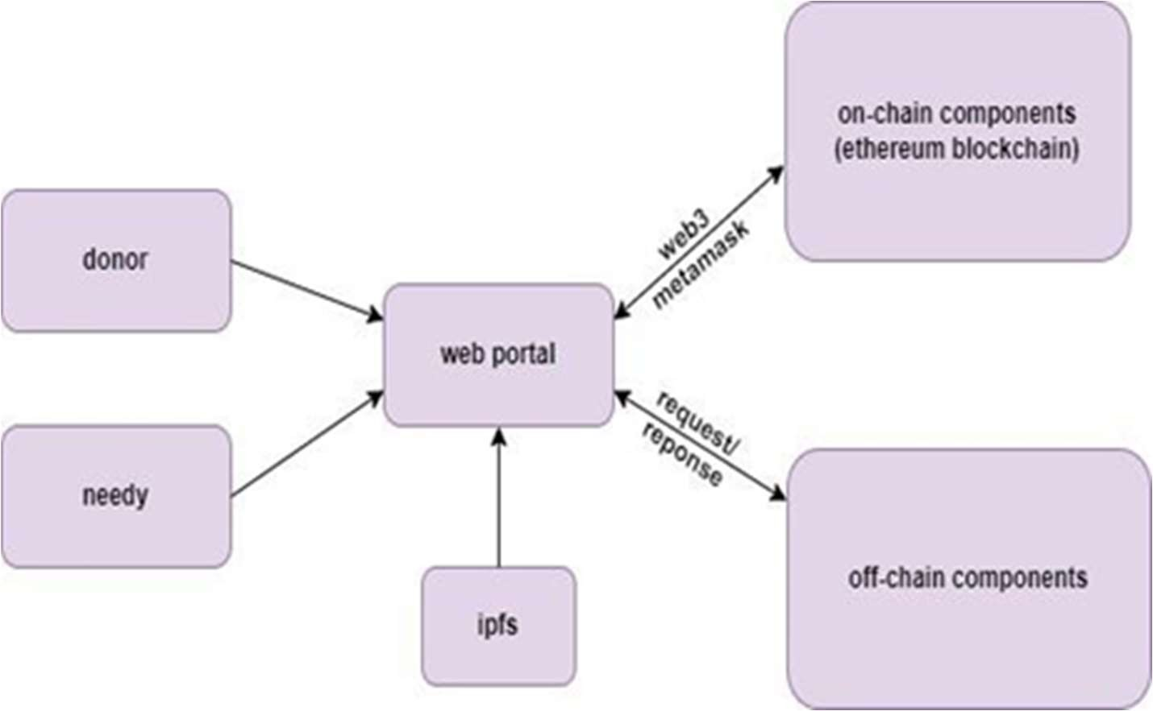

**Figure 1-Overview of Model**

There are multiples of disaster calamities occur for example drought, earthquake so more than half of the earth's land surface is susceptible to drought, making it a common and unexpected natural disaster. In recent decades, India has experienced frequent and severe droughts (once every three years), making it one of the world's most vulnerable nations when it comes to droughts. Notably, several areas of Gujarat and Rajasthan state (in the west of the country) have recently experienced a severe drought. These areas experience droughts as a result of unseasonably high temperatures, unfavorable weather patterns, and unlucky monsoon seasons.

In conclusion, disaster management using blockchain offers a transformative approach to address the limitations of traditional systems. By leveraging blockchain technology and its inherent characteristics, stakeholders can improve coordination, transparency, and data integrity throughout the different phases of disaster management. Understanding the technology and the classification of disaster management efforts is crucial for harnessing the full potential of blockchain in mitigating the impact of disasters and building resilient communities.

# CHAPTER 2

## LITERATURE SURVEY

Before starting this procedure, we plan to scan and double-check a number of source papers to ensure the accuracy of our work. Here is the introduction to the paper that will be scanned before we go to work on this task. Recent years have seen a substantial increase in interest in blockchain technology as a result of its potential to provide decentralized, secure, and transparent systems that can aid in disaster management. In this literature survey, we will explore the existing research on disaster management using blockchain technology.

Blockchain technology is anticipated to fundamentally alter how transactions are carried out, having an impact on a wide range of potential application areas[1]. According to a research by Sachin Kamble, Angappa Gunasekaran, and Himanshu Arha titled "Understanding the Blockchain technology adoption in supply chains Indian context," blockchain technology may have extensive applications in disaster management. The authors outline the primary areas where blockchain can be useful and talk about the prospects and problems of using it in disaster management. The report also presents a comprehensive review of the literature on blockchain-based catastrophe management systems and identifies the research gaps that require further investigation.

Understanding the adoption requirements for blockchain technology is crucial given its rapid development and the range of uses it provides. The capacity maturity model, which is the most often used, is the foundation for the maturity model's many aspects, which are examined using the comparative analysis approach [3]. The five stages of maturity (stages 1 through stage 5) from the CMM are modified to assess the BCMM( blockchain maturity model)'s maturity level. (1) A service can be described as Initial, which describes the haphazard and ad hoc state of a new service; (2) Repeatable, which describes how some experiences are

taken from similar products; (3) Defined, which describes the stage at which a service is standard and documented; (4) Managed, which describes the standard metrics proposed for qualitative evaluation; and (5) Optimizing, which describes how the service is continuously optimized and improved.

According to a study, a disaster management system based on blockchain and the Internet of Things (IoT) is suggested. The authors outline the proposed system's architecture and talk about the advantages of utilizing blockchain and IoT for disaster management. The research also provides a simulation of the suggested system and assesses how well it performs in various catastrophe scenarios. On the one hand, because of their sheer volume, IoT devices will generate transactions at a rate that existing blockchain systems cannot handle. On the other hand, the integration of Blockchain peers onto IoT devices is prohibited by resource constraints. This makes it impossible for both technologies, as they stand, to be directly integrated. In that article, they offer an answer to these problems by bridging the gap with a local peer network [4]. This type of design is suggested in order to do away with the necessity for a middleman and the associated processing fees while giving humanitarian supplies. Internet of things (IoT) technology is quickly developing, making it possible to link many useful products to the internet and provide new information and capability techniques for application purposes. IBM has put up a Blockchain-based solution, however it has not yet been put into practice [10].

Users can access services provided by many suppliers using a mobile or web application. For instance, their telecom operator may offer mobile wallets for use in payment transactions. Important features of this system include the automatic tracking of registered users' whereabouts, the delivery of real-time weather updates, analytics to help with the early detection of missing persons, and the presentation of the locations of services like shelter and food. The Internet of Things is essential for locating residents and supplies. Residents and moving cars can be followed using mobile or satellite phones [6]. The government of India's National Disaster Management Authority maintains a website and an app for managing disasters. The programme can be utilized by the user a guide to understanding natural

disasters past, present, and future, emergency supplies, etc. It provides instructions on how to call a helpline using the built-in calling feature[9]. They are unable to access the vast human resource reserves required to support the rescue effort, despite the fact that it makes people more conscious.

The Smart America project encourages its participants to create cyber-physical systems in order to save lives, create jobs, aid businesses, and strengthen the economy. One of the SERS initiatives for the Smart America challenge was the smart emergency response system. SERS is largely used to save lives. The system gives emergency workers and survivors the information they need to find and help one another in the event of a tragedy. Through SERS, which links first responders, software, search-and-rescue dogs, robotics, drones, autonomous planes, and ground vehicles, assistance requests can be sent to a mission center .[10]

The underlying qualities of blockchain technology may already be described, despite the fact that it is still a developing technology with opportunity for advancement in terms of technical elements and efficiency. The identified peer-reviewed publications and the correspondingly specified properties are provided in the concept matrix in order to evaluate these traits in a structured and methodical way. Our analysis demonstrates that blockchain technology brings a number of qualities to bear, which are examined in the next section in relation to one another to derive a list of important traits. For instance, when information is made publicly available between members without being influenced by a third party, it is expected that the traits "shared and public" as well as "low friction" lead to improved transparency in a system. By utilizing blockchain technology, individuals can create a connection that is openly and publicly unfolded. Participants have complete disclosure of system operations since there is a shared picture of all completed and ongoing transactions [3].

Since there is no central controller of the system, new transactions are broadcast throughout the entire network [6], and users can communicate directly with one another, there is less friction. Since direct interaction is secured using public-key cryptography and because the technology is transparent, every user can verify broadcasted transactions based on predefined

rules, trust may also be facilitated by this feature, which ensures the integrity of data stored in the database itself [6]. The database's immutable nature, which ensures that a transaction cannot be changed once it has been committed to a block, which is then put to the blockchain, also helps to build confidence. By using a so-called consensus mechanism, which, for example, necessitates the computation of a proof-of-work, this process is facilitated. A proof- of-work can be thought of as a difficult computational challenge that can be solved but is not difficult for others to verify. In the event that a user discovers the answer, they communicate it to the other network members so they may confirm it is accurate and come to an agreement on the answer.

**Description Table**

|  |  |  |  |  |
| --- | --- | --- | --- | --- |
| S NO. | Title | Author | Observation | Limitations |
| 1. | Blockchain | Seebacher, S., & | Decentralization | Not |
|  | Technology as an | Sch, R. (2017) | allows for the | implemented |
|  | Enabler of Service |  | protection of | in existing |
|  | Systems : A Structured |  | privacy, through | system, it’s a |
|  | Literature Review |  | pseudonymization, | literature |
|  |  |  | and creates a | review. |
|  |  |  | reliable and |  |
|  |  |  | versatile setting |  |
| 2. | Understanding the | Kamble, S., | The model is based | Assumption: |
|  | Blockchain technology | Gunasekaran, | on the integration of | Supply chain |
|  | adoption in supply | A., & Arha, H. | three adoption | practitioner’s |
|  | chains Indian context. | (2018). | theories- | familiarity |
|  | International Journal |  | technology | with |
|  | of Production |  | acceptance model | Blockchain |
|  | Research |  | (TAM), technology | Technology |

|  |  |  |  |  |
| --- | --- | --- | --- | --- |
|  |  |  | readiness index (TRI) and the theory of planned behavior (TPB) | in supply chains |
| 3. | A maturity model for | Wang, H., Chen, | The comparative | Blockchain |
|  | blockchain adoption. | K., & Xu, D. | analysis method is | system is not |
|  | Financial Innovation. | (2016). | used to analyze | yet at an |
|  |  |  | different | optimum |
|  |  |  | dimensions of the | maturity level |
|  |  |  | maturity model, | and should |
|  |  |  | which is mainly | conduct |
|  |  |  | based on the | extensive |
|  |  |  | commonly used | feasibility |
|  |  |  | capability maturity | studies before |
|  |  |  | mode. | implementati |
|  |  |  |  | on. |
| 4. | Scalable Blockchain | Sujit Biswas, | IoT offers | Not evaluated |
|  | Framework for Secure | Kashif Shaif, | automation at the | using real |
|  | Transactions in IoT. In IEEE Internet of Things Journal | Boubakr Nour, Yu Wang and Fan Li., October (2018). | finest level in different fields, while Blockchain provides secure  transaction | time transactional data. |
|  |  |  | processing for |  |
|  |  |  | asset exchanges. |  |
| 5. | Blockchain-centric | Vinayak G. | This paper propose | Latency in |
|  | Resource Management | Bhat, H. P. | a resource | transaction. |
|  | System for Disaster | Pranaav, | management |  |
|  | Response and Relief . | S. Mini, Deepak | system to tackle the |  |
|  |  | Tosh. (2021) | issue of extensive |  |
|  |  |  | paperwork for |  |
|  |  |  | deployment of |  |
|  |  |  | relief material |  |
|  |  |  | through a |  |

|  |  |  |  |  |
| --- | --- | --- | --- | --- |
|  |  |  | blockchain based web application using Hyperledger Fabric. |  |
| 6. | Use case of Blockchain in Disaster Management- A Conceptual View . | G.V. Sobha, P. Sridevi. (2021) | This paper focuses on how blockchain can be used as an application during emergencies. | Not implemented in existing system contains only conceptual view. |
| 7. | Decentralizing Privacy: Using Blockchain to Protect PersonalData. | Zyskind, G., & Pentland, A. S. (2015). | This paper contains information about combination of blockchain and off blockchain storage to construct a personal data management platform focused on privacy. | Only suitable for storage of data but not for processing of data. |
| 8. | Information technologies and disaster management – Benefits and issues[8] | Sakurai, M. & Murayama,Y. (2019) | The paper presents brief examples of use of information technology in different disaster management stages such as disaster response, recovery, | No decentralized implementati on. |

|  |  |  |  |  |
| --- | --- | --- | --- | --- |
|  |  |  | preparedness and risk reduction. |  |
| 9. | Blockchain & Infrastructure (Identity, Data Security). | Shrier, D., Wu, W., & Pentland,  A. (2016). | This paper focuses on how blockchain can management system to tackle the issue of extensive paperwork | Not implemented |
| 10. | Beyond Bitcoin  Enabling Smart Government Using Blockchain Technology | Svein, Ø. (2016). | The comparative analysis method is used to analyze different dimensions of the maturity model | Only suitable for storage. |

# CHAPTER 3

## PROPOSED WORK

### Problem Statement

The objective is to collaborate various stakeholders like government, Non- government, disaster team, transportation, energy, communication services, hospitals, rehabilitation centers, financial services, local government, residents to one platform where information are exchanged and secured for effective management and recovery at the time of disaster.

### Feasibility Study

This survey is being conducted to better handle the disaster situation by providing fundings. Current Disaster systems have closed the gaps of various problems in disastrous situations but there are a lot of issues in current existing disaster management systems. There are no focuses on the smooth transactions for preventing them from the frauds. There are lack of trust among the concerned authorities, NGOs and donators in the transactions and data shared on these systems as they can be tampered easily. The problem statement of this research paper is to use the blockchain technology to make the decentralized application in which problems of transparency, security, latency will be improved and various concerned entities will take part in the blockchain nodes to see the details of transactions happening.

### Proposed Research Work

The system is designed to keep the following features.

1. Volunteers can register on the network to donate certain resources. They can also register themselves as human resources. This allows various enterprises including the government to view the volunteers list according to the registered resources, location wise if needed.
2. Collecting donated goods from individual volunteers can be cumbersome, hence the concept of local hubs is introduced to aggregate the donations over a fixed area before they are transported by logistics.
3. Victims can register on the system to access relief material. In case a victim is unable to register on his own he may approach any relief camp nearest to him.
4. Allowing collaboration between different enterprises on the network.

**User Scenario 1 :**

User Requesting for Aid When disaster hits, users request assistance to rescue themselves and their family and friends. Once the request for aid has been made to the network, every stakeholders in the network can access the location, and person or the team near to the location will send an acknowledgement back to the network that the team is ready to rescue. When this acknowledgement receives, with no delay, the respective rescue team will respond to the request and rest of the rescue teams and other stakeholders can work on other request as well. Since the information is transparent and secured, no data consistency or integrity do occur. Once the rescue team done their emergency operation, the information will be again propagate back to the network for the confirmation of work and the data is stored in the blockchain with timestamp. The system model for rescue aid is shown in Figure.

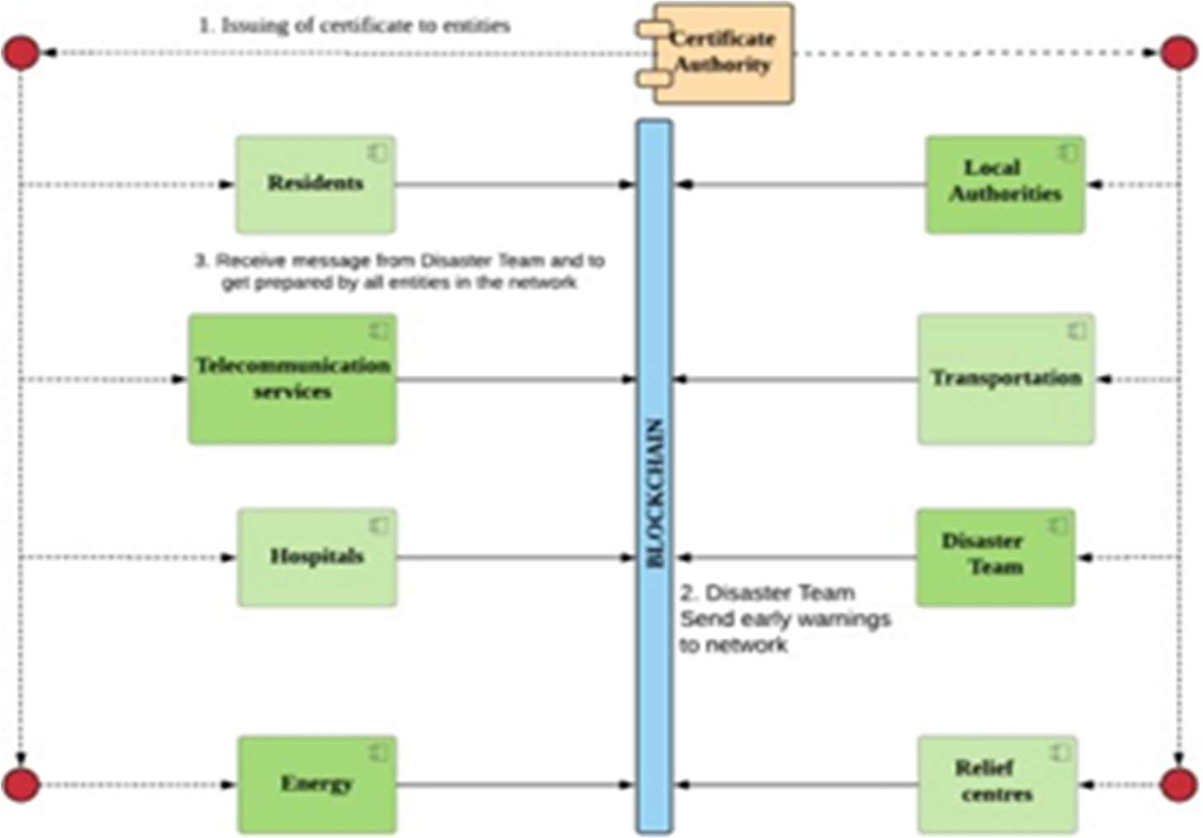

**Figure 2- System Model for Registration and early Warning**

**User Scenario 2: During Recovery Phase**

The recovery phase will make use of the data that was gathered during the catastrophe response phase. Blockchain will assist in keeping track of all the information saved in the blockchain so that the overall damages and the amount of resources consumed can be determined. Blockchain can actually offer valuable and reliable information to make strategic decisions, whether it's to issue a victim certificate or release funds for the recovery process. As the information saved in the network is transparent and unalterable, everyone may see exactly where the disaster management process stands at any time.

In addition to the aforementioned user scenario, a number of other related issues can arise both during and after a disaster, including: locating the closest relief centre, fear that a disease will spread, interruptions in the power supply, unequal distribution of water and food, locating the missing, statistics on the number of affected people and the extent of their damages, shipping issues, providing suffered authenticated certificate for future welfare, fraudulent behaviour intended to steal people's welfare, etc. All of these issues might potentially be quickly and clearly resolved with blockchain technology.

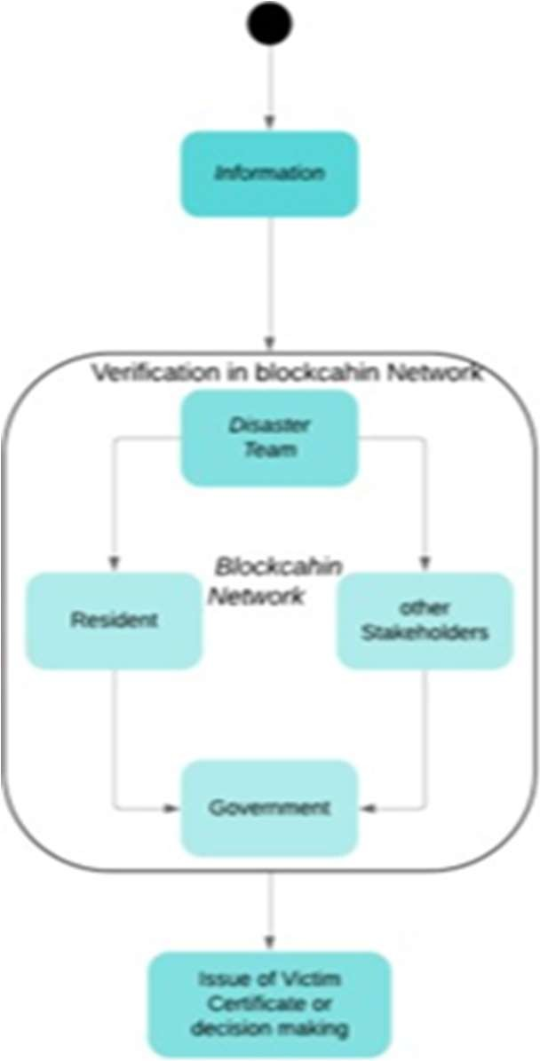

**Figure 3- Verification of information**

### Key Terminologies

1. **Web3**

Web3.0 is another name for Web3.A new version of the World Wide Web that combines ideas like decentralisation, blockchain technology, and token-based economics is proposed in some journalists and technologists have compared it to Web 2.0, where they claim that content and data are concentrated in a select few businesses that are sometimes referred to as "Big Tech." Gavin Wood, a co-founder of Ethereum, popularised the phrase "Web3" in 2014, and venture capital firms, cryptocurrency enthusiasts, and major technological businesses began to show interest in the concept in 2021.

Gavin Wood, the inventor of Polkadot and a co-founder of Ethereum, first used the phrase "Web3" in 2014 to describe a "decentralised online ecosystem based on blockchain." The

idea of Web3 became more well-known in 2021. A surge in interest occurred towards the end of 2021, partly as a result of investments made by well-known organisations and technologists and curiosity from cryptocurrency aficionados. In October 2021, executives from the venture capital firm Andreessen Horowitz visited Washington, D.C., to advocate for the concept as a potential response to legislators' ongoing concerns about web regulation.

#### IPFS

Data can be stored and shared in a distributed file system using the protocol, hypermedia, and peer-to-peer network known as IPFS. Each file in a global namespace connecting IPFS servers is uniquely identified via content-addressing, which is used by IPFS. The World Wide Web can be distributed using IPFS instead of the location-based hypermedia server protocols http and https.

Similar to BitTorrent, IPFS enables users to host and receive content. IPFS is designed around a decentralised system of user-operators who each retain a fraction of the total data, as opposed to a centrally located server. This results in a robust system for storing and distributing files. Other peers in the network can locate and request that content from any node who has it using a distributed hash table (DHT), and any user in the network can serve a file by its content address.

1. **Ethereum**

Blockchain technology underpins the decentralised, international software platform known as Ethereum. It is best known for ether (ETH), a native cryptocurrency. Anyone can use Ethereum to develop any secure digital technology. It has a token created to compensate users for work done in favour of the blockchain, but if accepted, users may also use it to pay for material products and services. Scalable, programmable, secure, and decentralised are all features of Ethereum. It is the blockchain of choice for programmers and businesses building technology atop it to transform numerous sectors and how we go about our daily lives. Smart contracts, a key component of decentralised apps, are natively supported. Smart contracts and blockchain technology are used in many decentralised finance (DeFi) and other applications.

### Software Requirement Specification

ReactJs NextJs Solidity Blockchain

* 1. **Libraries** Metamask Hardhat

Infura IPFS

### Operating System

(a)Windows or Ubuntu

# CHAPTER 4

## IMPLEMENTATION AND RESULT DESCRIPTION

### TOOLS REQUIRED FOR IMPLEMENTATION

* + 1. **Next.js**

Next.js is a React framework that is open-source and widely used for creating web applications. It was created by Vercel( previously known as Zeit) and offers various features that simplify the process of building and deploying React applications, making it faster and easier.

The framework includes several noteworthy features. For example, it enables server-side rendering (SSR) by default, which pre-renders web pages on the server and sends them to the client as complete HTML, CSS, and JavaScript. This has the potential to improve page loading times and SEO. Additionally, Next.js automatically splits JavaScript code into smaller, more manageable chunks that can be loaded as needed, reducing the amount of code that must be downloaded and parsed by the browser, thereby enhancing performance.Next.js is also capable of generating fully static sites that don’t require server rendering, which is advantageous for websites that don necessitate dynamic content or real-time data. The framework also includes automatic optimization features such as image optimization, code minification, and caching, which can help improve performance and decrease the amount of data required for download. Finally, Next.js has built-in support for TypeScript, a static language that can help identify errors and improve code quality. Overall, Next.js is a versatile and robust framework for developing React applications that emphasizes performance and user-friendliness.

* + 1. **Visual Studio Code**

Visual Studio Code is a source-code editor that supports Java, JavaScript, Go, Node.js, and Python, among other programming languages. It&#39;s built on the Electron framework, which is used to create Node.js Web apps that leverage the Blink layout engine. The same editor component (codenamed &quot;Monaco&quot;) that is used in Azure DevOps is used in Visual Studio Code (formerly called Visual Studio Online and Visual Studio Team Services). Visual Studio Code comes with rudimentary support for the majority of programming languages out of the box. Syntax highlighting, bracket matching, code folding, and customizable snippets are all included in this basic package.

* + 1. **React.JS**

A well-liked JavaScript package called ReactJS is used to create user interfaces (UIs) for web applications. It was created by Facebook, and Facebook and a developer community currently jointly maintain it. React enables programmers to design reusable user interface (UI) elements that may be combined to create complex user interfaces (UI). Developers specify how the user interface (UI) should look and function, while React takes care of updating the UI when data changes. This approach is known as a declarative approach.

React JS ability to quickly adapt the user interface in reaction to data changes is one of its key advantages. This is accomplished by utilizing a virtual DOM, which is a simplified version of the real DOM that React utilizes to track changes. React determines the most effective approach to update the actual DOM after updating the virtual DOM whenever data changes.

Redux for controlling application state and React Native for creating mobile applications are two libraries and frameworks that are frequently combined with React. There are many resources available for learning and problem-solving because it has a sizable and vibrant developer community.

Additionally, there is a sizable and active developer community for ReactJS, which means there are a lot of learning and problem-solving resources available. It is simple to create intricate and sophisticated online apps because to the abundance of open-source modules and tools that can be used to extend and improve ReactJS applications.

In conclusion, ReactJS is a robust and adaptable JavaScript toolkit that is frequently used to create online apps that are quick, scalable, and modular. Building dynamic and interactive UIs is made simple by its component-based architecture, virtual DOM, use of state, and props, and its vast and vibrant developer community guarantees that there are always cutting- edge tools and resources accessible.

* + 1. **Blockchain**

Blockchain is a distributed ledger technology that is used for recording and verifying transactions without the need for a central authority. It operates as a decentralized database where transactions are recorded in a secure, transparent, and tamper-proof manner. Each block in the chain contains a record of multiple transactions, which are verified by a network of nodes through a consensus mechanism. One of the key features of blockchain is its immutability. Once a transaction is recorded on the blockchain, it cannot be altered or deleted, making it an excellent tool for ensuring the integrity of data. The use of cryptography to secure the transactions and the distributed nature of the network also make blockchain highly resistant to hacking and other malicious attacks.

Blockchain has numerous applications, with cryptocurrency being one of the most well- known. However, it is also being explored for use in supply chain management, identity verification, voting systems, and many other areas. The potential benefits of blockchain include increased transparency, efficiency, and security, as well as the ability to reduce costs and improve trust in transactions.

* + - 1. **Metamask**

For storing, administering, and interacting with cryptocurrencies and decentralised apps (dApps) based on Ethereum, MetaMask is a browser extension. It is accessible for main browsers including Chrome, Firefox, Brave, and others. For managing cryptocurrency funds, MetaMask offers a user-friendly interface that makes it simple for users to send, receive, send, and acquire Ethereum-based assets. Additionally, it allows users to interact with decentralised applications (dApps), or applications built on the Ethereum blockchain and providing a range of services like games, financial services, and marketplaces.

Installing the extension on their browser and making a wallet with a public address and private key are prerequisites for using MetaMask. When users buy Ethereum or other comparable tokens on a platform, they can then add money to their wallet. Connectivity to other Ethereum networks, such as the Ethereum mainnet and various testnets, which are alternate implementations of the Ethereum blockchain used for testing and development, is one of MetaMask's core advantages. This makes it simple for consumers to switch between networks and try out various dApps without putting their mainnet money at danger.

* + - 1. **Infura**

Infura is a web3 infrastructure provider that offers developers a simple and reliable way to connect to blockchain networks. It provides a set of APIs that enable developers to interact with Ethereum, IPFS, and other blockchain networks without having to run their own node. Infura takes care of the node maintenance, upgrades, and scaling, allowing developers to focus on building their applications. Infura was launched in 2016 by ConsenSys, one of the leading blockchain development companies. Its mission is to help accelerate the adoption of decentralized applications by removing the technical barriers associated with running blockchain nodes. With Infura, developers can build decentralized applications without having to worry about the infrastructure and maintenance required to run a node.

Infura supports both the Ethereum mainnet and testnets, as well as other Ethereum-based networks such as Rinkeby, Kovan, and Ropsten. It also supports IPFS, a decentralized file storage and sharing system, making it easy for developers to store and retrieve files on the IPFS network. Infura has become a popular choice for many developers building decentralized applications, as it provides a reliable and scalable infrastructure that can handle large amounts of traffic. It has also been used by many blockchain startups and projects to connect to the Ethereum network and access smart contracts. In summary, Infura is a web3 infrastructure provider that offers a simple and reliable way for developers to connect to blockchain networks, without having to run their own node. It supports Ethereum and IPFS, and has become a popular choice for many developers building decentralized applications.

#### IPFS

A decentralized method for exchanging and storing files is called IPFS (InterPlanetary File method). It is intended to be a more effective and dependable substitute for the conventional client-server internet approach. When a user requests a file, the server distributes it to them according to the conventional client-server architecture. However, with IPFS, files are kept on a network of computers known as nodes, and whenever a user requests a file, they get it from the node that has a copy of it. Files may be accessible more quickly and are less likely to be lost or damaged because to this decentralized approach.

A special addressing scheme used by IPFS is based on content rather than place. IPFS (InterPlanetary File System) is a decentralized system for transferring and storing files. It is meant to be a more reliable and efficient alternative to the traditional client-server internet architecture. The server delivers files to users in accordance with the traditional client-server architecture when they request them. In contrast, IPFS stores files on a network of computers known as nodes, and anytime a user requests a file, they are provided by the node that is hosting a copy of the requested file. This distributed approach may make files more rapidly

accessible and less likely to be lost or corrupted. IPFS has a unique addressing technique that bases addresses on content rather than location.

#### FRONTEND

The front end of a software application is responsible for presenting the user interface and user experience to the end-users. It is the part of the application that users interact with directly, providing a visual and interactive representation of the underlying functionality. The frontend must be designed and implemented in a way that is intuitive and easy to use, while also providing access to all of the features and functionality of the application.

* + - 1. **React**

ReactJS is an open-source JavaScript library that is used for building user interfaces (UI) for web applications. Developed by Facebook, ReactJS provides a component-based approach to building UI, allowing developers to create reusable UI components that can be used across the entire application. It also allows developers to update the UI dynamically in response to user actions or changes in data, making it ideal for building single-page applications (SPAs) and dynamic UI. ReactJS uses a virtual DOM to efficiently update the UI, minimizing the amount of time needed for UI updates. With its popularity and large community, ReactJS has become a widely used and powerful tool for building modern web applications.

* + - 1. **Cascading Style Sheet (CSS)**

Cascading Style Sheets (CSS) is a styling language used to describe the presentation of a document written in HTML or XML. CSS is used to control the layout, fonts, colors, and other visual elements of a webpage, allowing developers to create a consistent and visually appealing user interface. CSS works by applying rules to HTML elements, defining how they should be displayed in the browser. CSS supports a wide range of selectors, allowing

developers to target specific elements on a page. It also includes advanced features like media queries, animations, and responsive design, making it a powerful tool for creating modern, interactive web applications.

#### BACKEND

The backend of a software application is responsible for handling the business logic, data storage, and server-side processing. It provides the necessary functionality and services to the frontend, often through a RESTful API. The backend is responsible for processing requests, executing logic, interacting with databases, and generating responses.

* + - 1. **Express.JS**

Express.js is a popular open-source web framework for building server-side applications using Node.js. It provides a set of features and tools for building web applications, including routing, middleware, templating, and error handling. Express.js is highly customizable and flexible, allowing developers to create APIs, web apps, and even full-stack applications. It has a large and active community that has developed a wide range of plugins and extensions to extend its functionality. With its simplicity and ease of use, Express.js has become a popular choice for building server-side applications, making it an essential tool for Node.js developers.

* + - 1. **MongoDB**

MongoDB is a popular open-source NoSQL document database that stores data in flexible, JSON-like documents. It is designed to be highly scalable and performant, making it ideal for handling large amounts of data and high-traffic applications. MongoDB uses a flexible data model that allows developers to easily store and retrieve complex data structures without the need for complex joins or schemas. It also supports a wide range of features, including

automatic sharding, replication, and dynamic queries. MongoDB has a large and active community that has developed a wide range of libraries, tools, and extensions to support its use, making it a popular choice for modern web applications.

* + - 1. **Node.JS**

Node.js is an open-source, cross-platform JavaScript runtime environment that allows developers to run JavaScript on the server side. It is built on the V8 JavaScript engine, the same engine used in the Google Chrome browser, which provides a fast and efficient runtime. Node.js provides an event-driven, non-blocking I/O model, making it ideal for building scalable and high-performance network applications. The backend of a software application is responsible for handling the business logic, data storage, and server-side processing. It provides the necessary functionality and services to the frontend, often through a RESTful API. The backend is responsible for processing requests, executing logic, interacting with databases, and generating responses.

It has a rich ecosystem of libraries and modules, making it easy to build web servers, APIs, and other server-side applications. With its popularity and versatility, Node.js has become a popular choice for building modern web applications, particularly those that require real- time, data-intensive, and scalable applications. It also supports a wide range of features, including automatic sharding, replication, and dynamic queries. MongoDB has a large and active community that has developed a wide range of libraries, tools, and extensions to support its use, making it a popular choice for modern web applications.

* 1. **PROJECT IMPLEMENTATION**
     1. **Working:**

1. The admin can create campaign according to the requirements. The admin can start the campaign and pay the gas price according to this. The user/donator can donate

through the campaigns started by admin and then they can donate through their meta mask account.

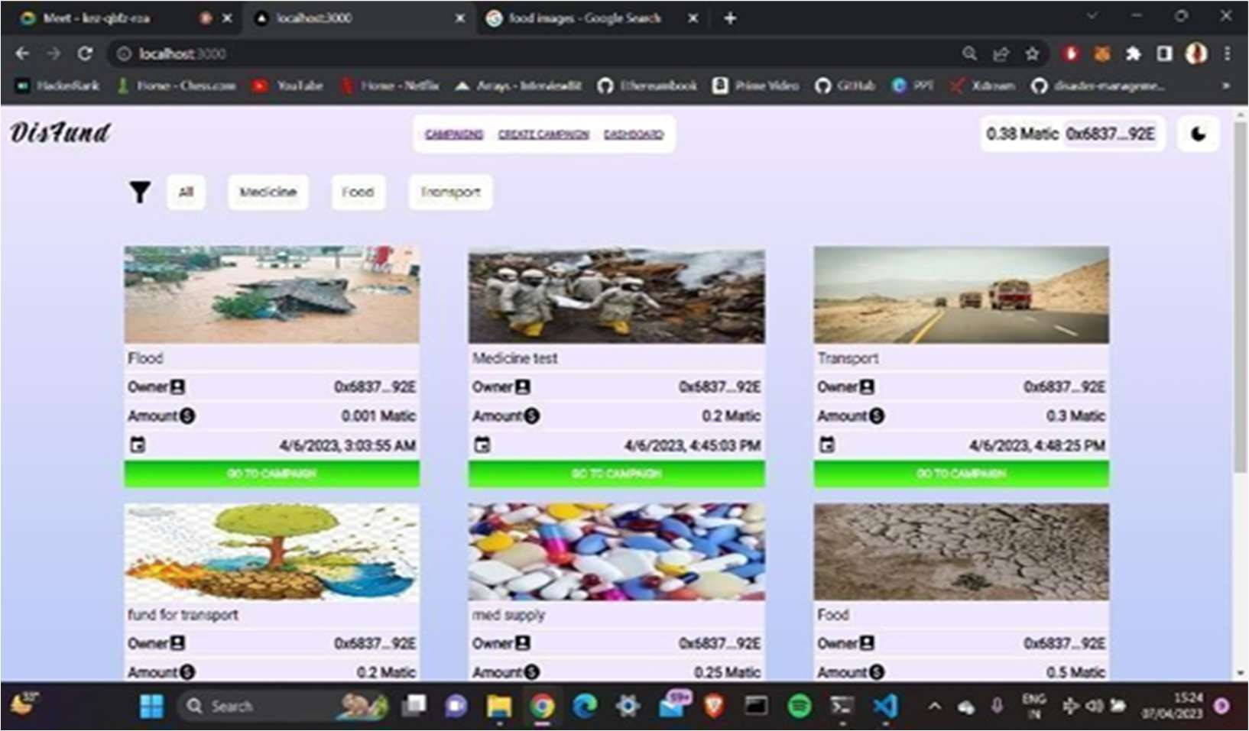

**Figure 4- Sample 1**

1. This is the screen of create campaign here the user will going to create the new campaign for which they need funding to be raised. Customers can check the status of the warranties on the products they have purchased using the warranty verification tool on this page. Customers must provide a special ID that they obtained from the seller on their registered email address in order to authenticate their warranty. This ID, which acts as a distinctive identification for the product, is often a string of letters and digits. The system scans the database once the customer inputs their ID to confirm the product's warranty status and then shows the pertinent data. Customers can use this tool to make sure their products are covered by warranty and can be repaired or replaced as needed.

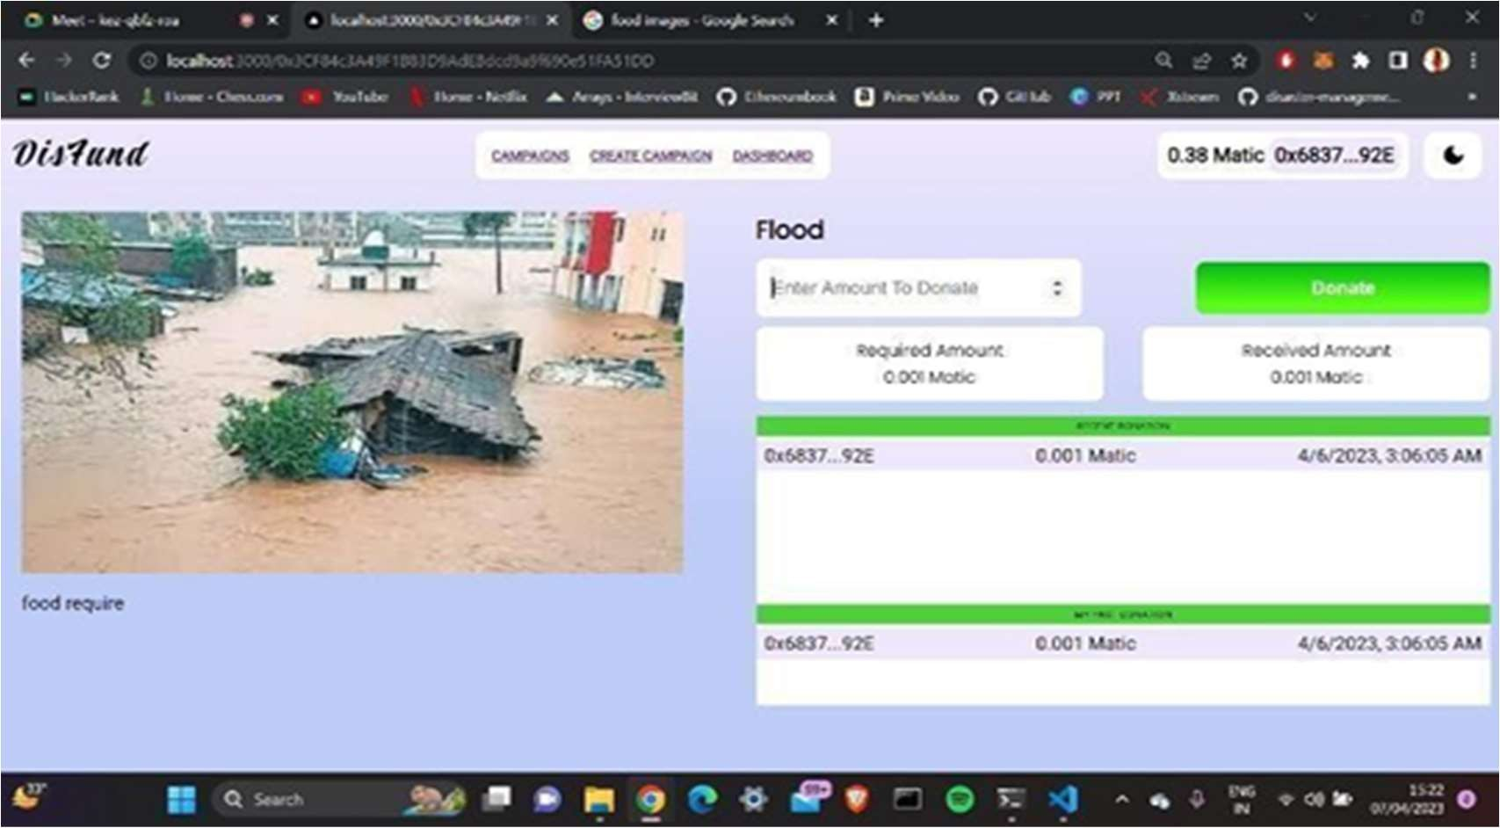

**Figure 5- Sample 2**

1. This platform's login page offers a customised login experience with distinct logins for users and merchants. While merchants use their specific login information to access their dedicated seller dashboard, users log in with their registered email address and password to access their user accounts. This strategy guarantees that users and sellers can safely accessed.

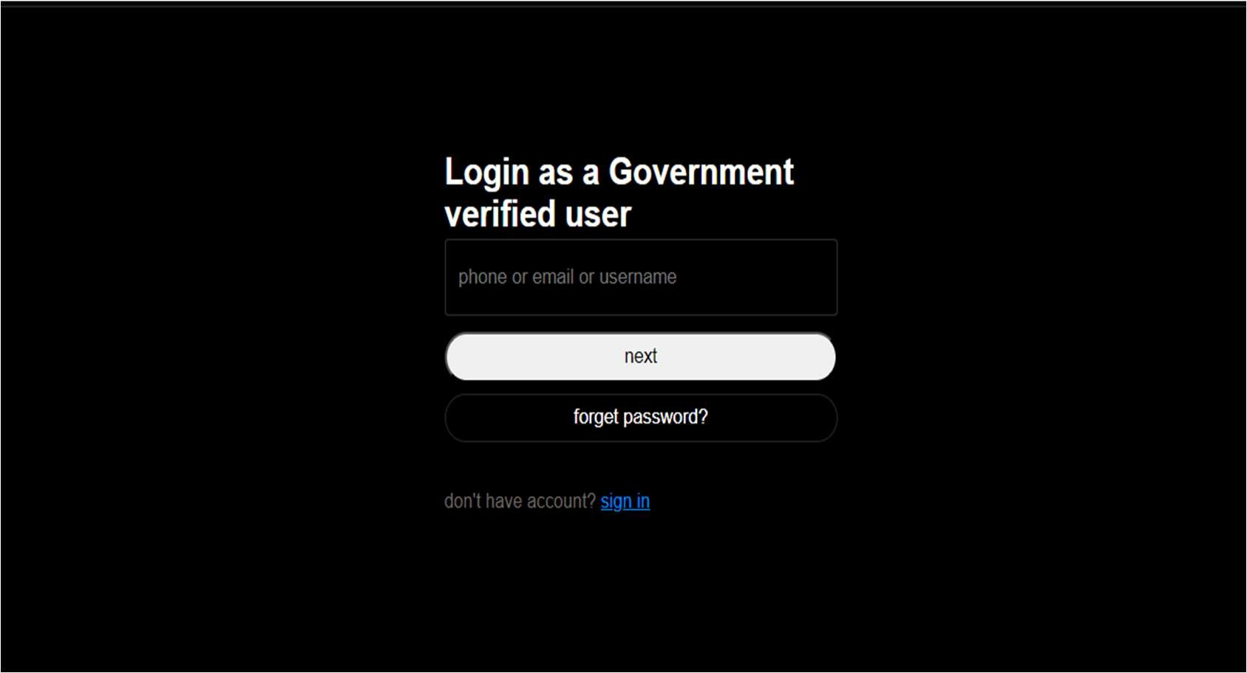

**Figure 6- Sample 3**

1. This platform's login page offers a customised login experience with distinct logins as a public.

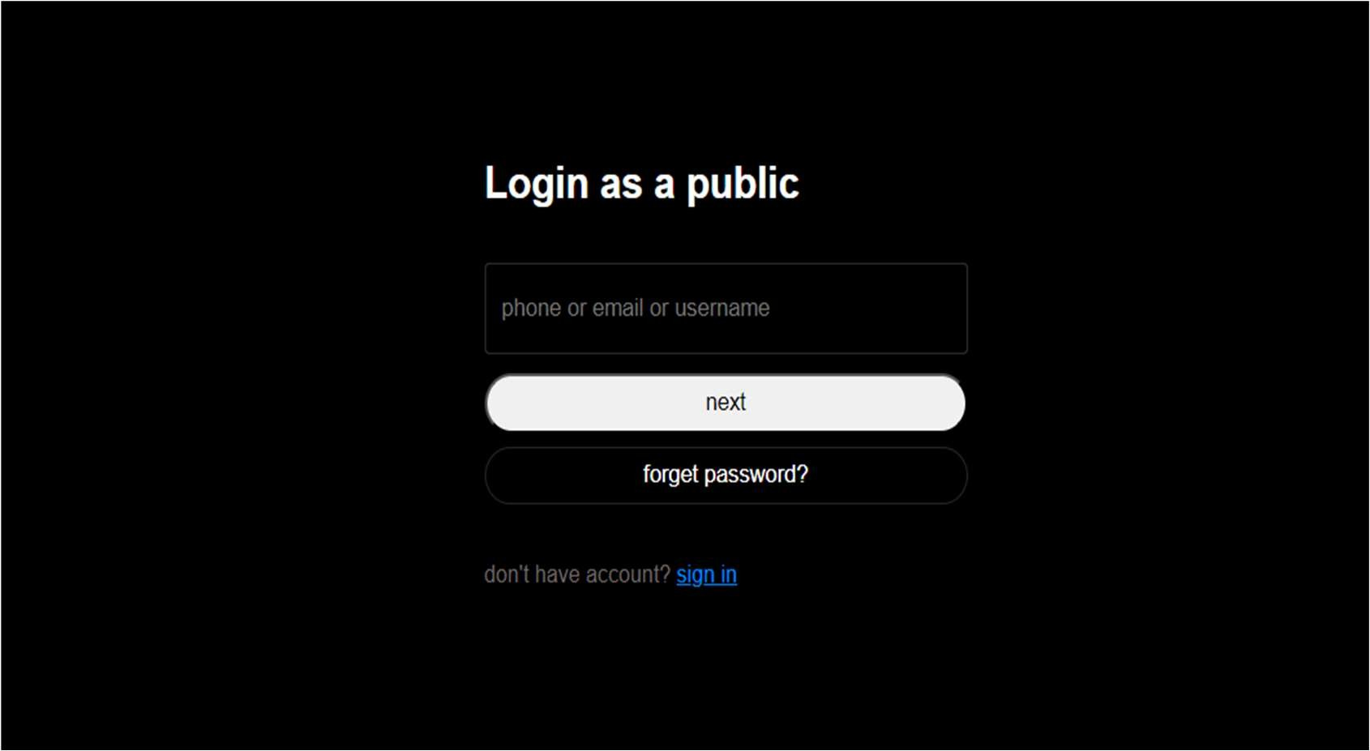

**Figure 7- Sample 4**

1. This is the dashboard screen which shows the campaign to the government verified user.

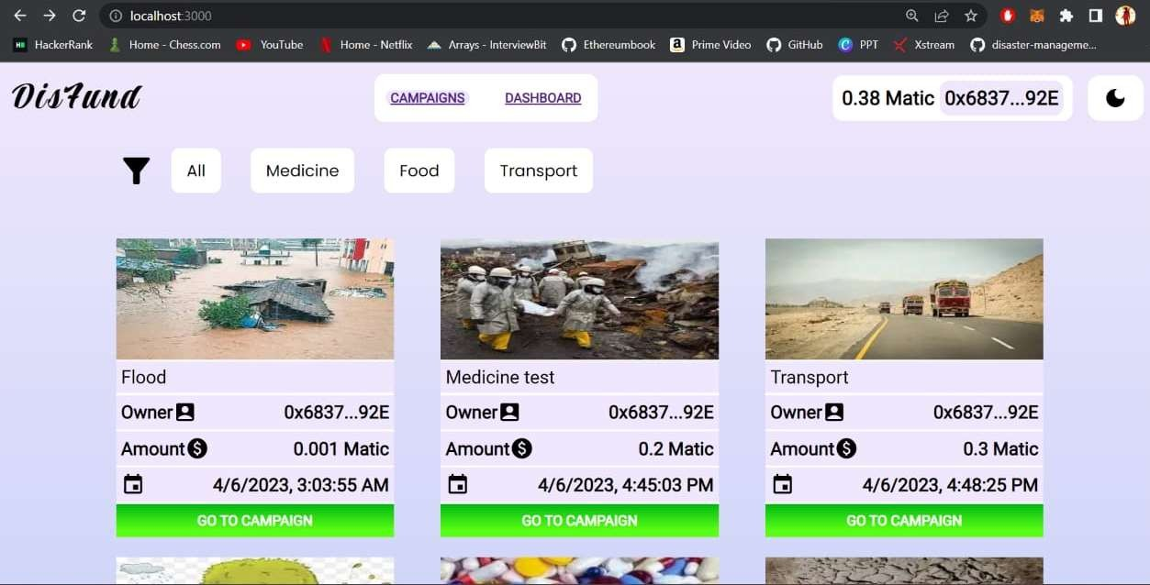

**Figure 8- Sample**

1. This is the dashboard screen which shows the campaigns created by a particular admin. In this the donations made by admin or the campaigns created by admin will be showed in the system. The admin can also make donations from their metamask account and also fetch their personal donations details from their admin panel dashboard.

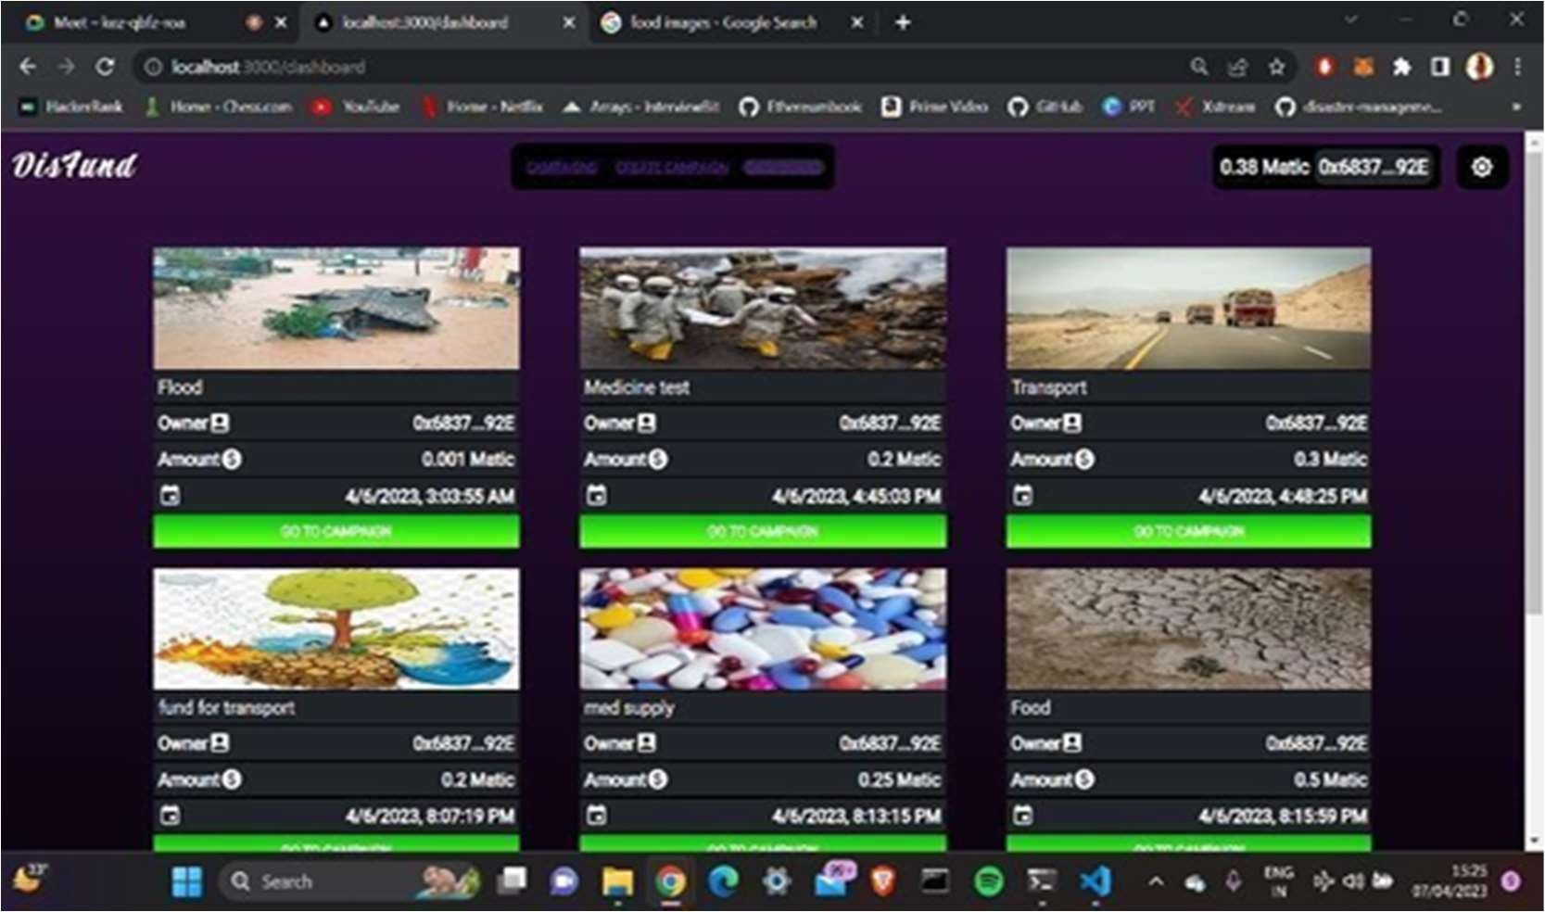

**Figure 9- Sample**

* + 1. **Code Explanation:**

The line // SPDX-License-Identifier: Unlicensed tells us the license we are working with. This would help us to prevent from any error.

pragma solidity >0.7.0 <=0.9.0 tells us the solidity version we are working on.

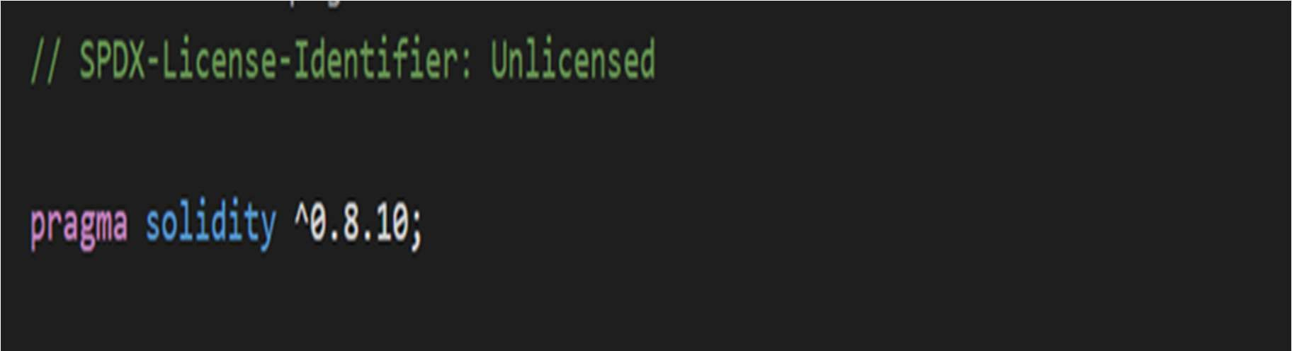

**Figure 10**

We will create the contract by calling the function contract and name it as “Campaign” . We will make these state variables as public function because we want to anyone to call it.

* State variables : These variables will be stored in the blockchain : -

title : It will be used to store the title of the campaign to be started by the requestor. It is of string datatype.

* RequiredAmount : It would be used to store the required amount requested by the users. It is of uint datatype.
* Image: We would save the link of the image as a string we get from IPFS as storing the image in the blockchain is very costly .
* Story : This variable will store the Reason or detail of the campaign.
* Owner : It would store the address of the creater or owner of the creator.
* ReceivedAmount : It would store the amount received from the donor.

We would use the event function to integerate the smart contract values with the frontend

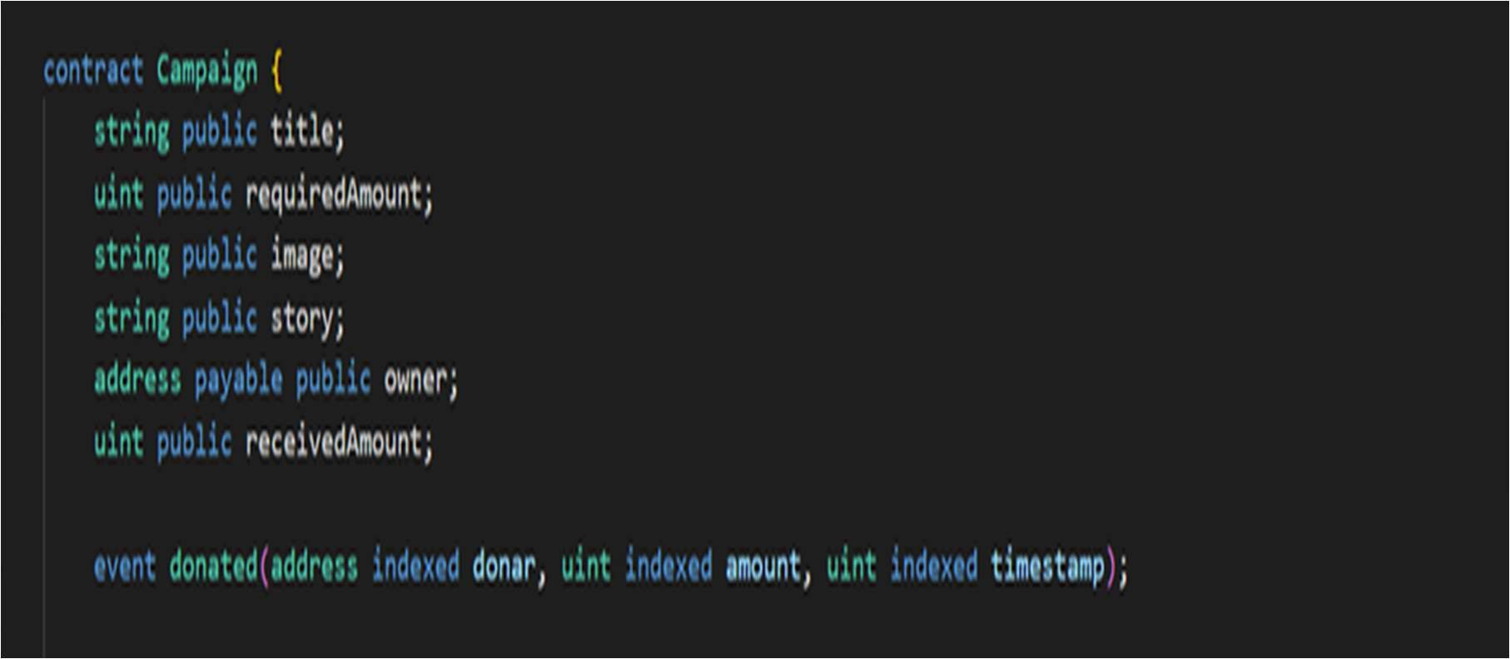

**Figure 11**

The Constructor Function:

* The constructor is the first function to run as we would make sure that only the creator of the campaign would call the contract.
* We can set argument with memory keyword so that these would not save in the blockchain and these will be used till we csll the constructor function
* The arguments in constructor are – campaignTitle, requiredCampaignAmount, imgURI, storyURI, campaignOwner
* These constructor would be assigned to the state variables as: title = campaignTitle;

requiredAmount = requiredCampaignAmount; image = imgURI;

story = storyURI;

owner = payable(campaignOwner);

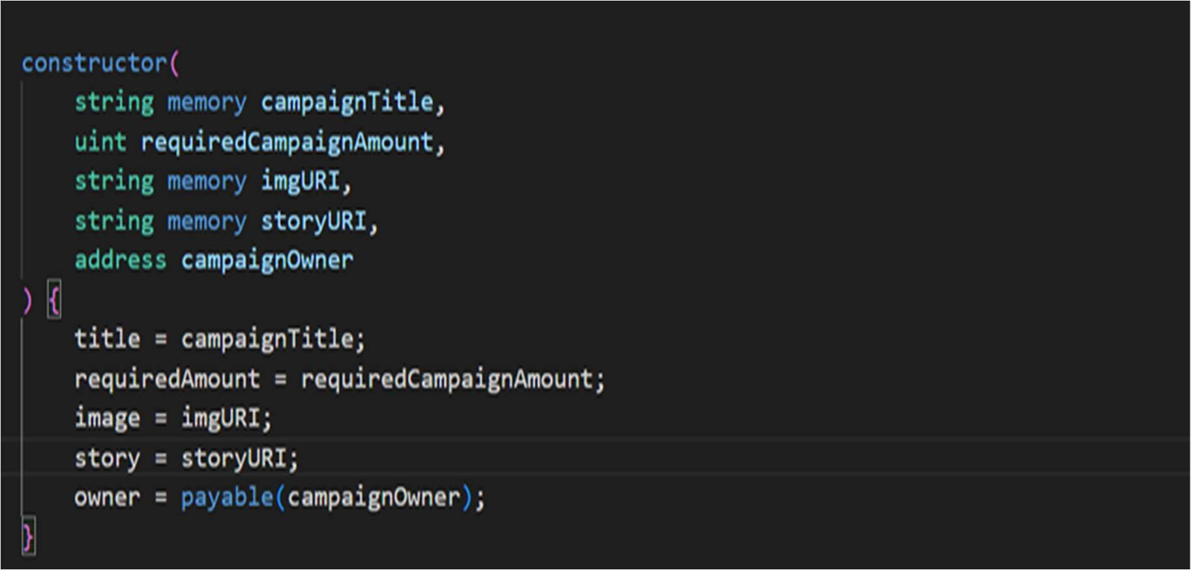

**Figure 12**

The Donation Function:

* This function is used to run the donation processs smoothly.
* We use the payable keyword if we want to receive or transfer the funds.
* msg.value is the global variable which is used to fetch the value of transaction or funds.
* msg.sender is a global variable which is used to fetch the value of owner.
* We would use receivedAmount += msg.value to increase the value of received amount whenever someone donate it.
* We would increase the received amount till (requiredAmount > receivedAmount) is satisfied.
* emit is used to get the values from donate function to use these with the frontend.
* block.timestamp is used to give the value of the current block running.

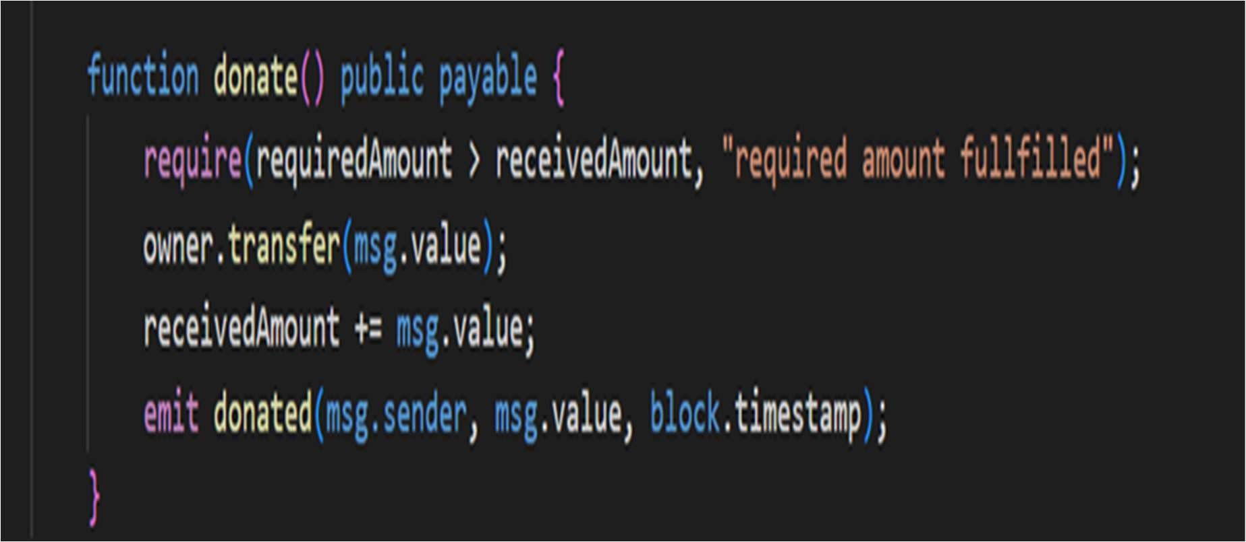

**Figure 13**

The Campaign Factory function :

* This function is used to store the deployed addresses of all the previous created contracts and functions.
* address[] public deployedCampaigns is used to store deployed addresses of campaigns.
* We would create new function to create the campaign as function createCampaign().
* emit campaignCreated() is used to fetch the values of createcampaign function for frontend use.

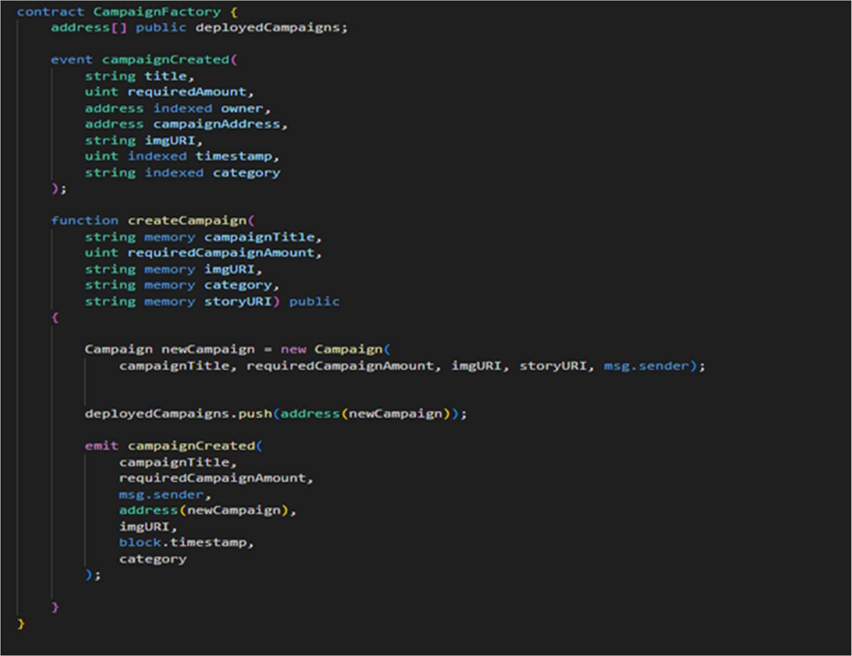

**Figure 14**

### Testing :

We will test the contract in the Remix IDE.

There are about four different environments, but we will use just two javascript VM(London) and Injected Web3.

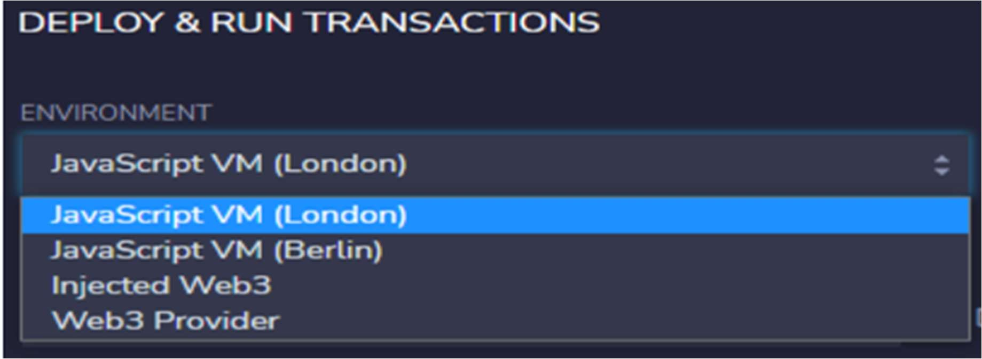

**Figure 15**

We will select the account in the Accounts tab.

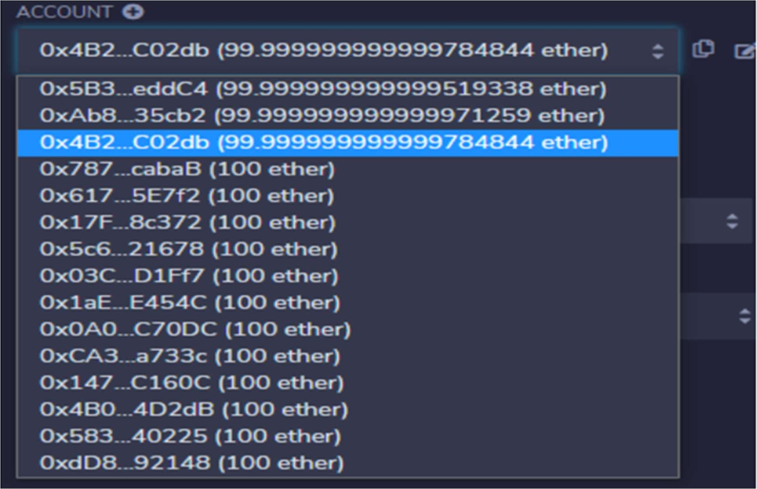

**Figure 16**

Compile the contract and click on deploy.

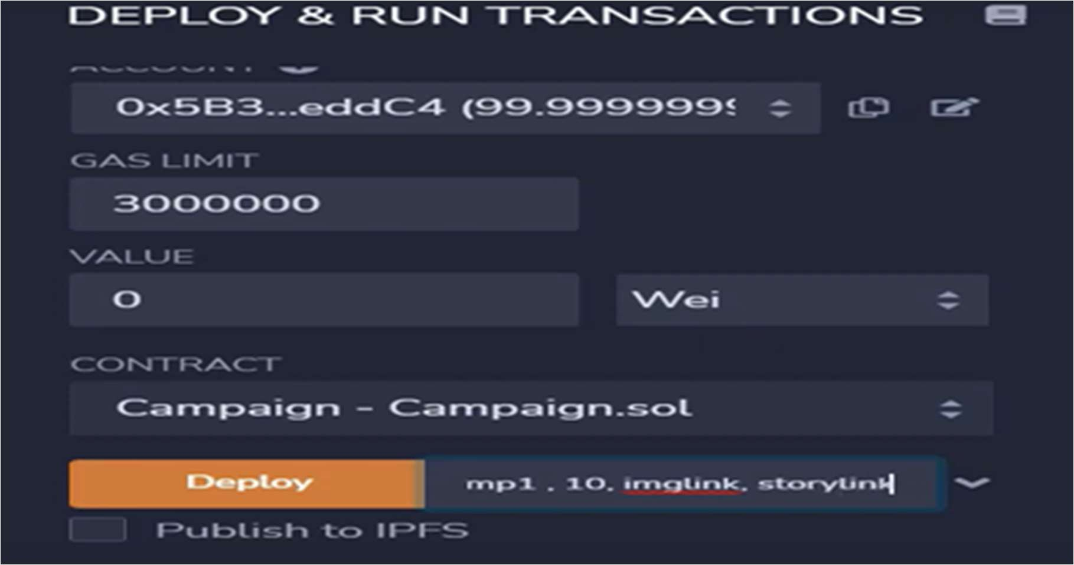

**Figure 17**

We can see the deployed contracts here:

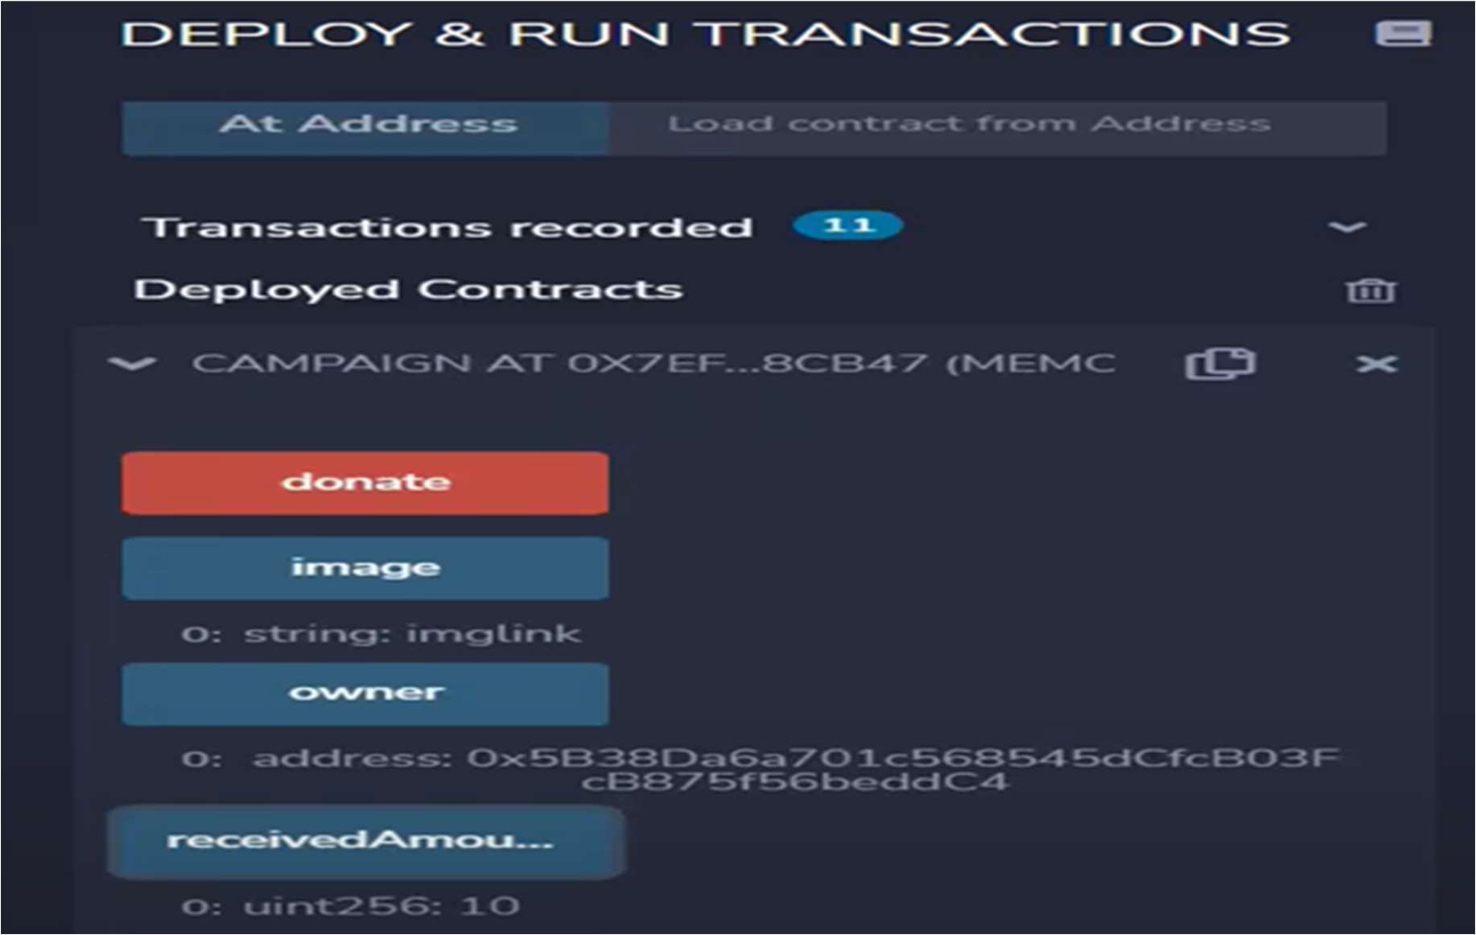

**Figure 1**

We can see the campaign factory function by entering the required values and see in the deployed contracts tab:

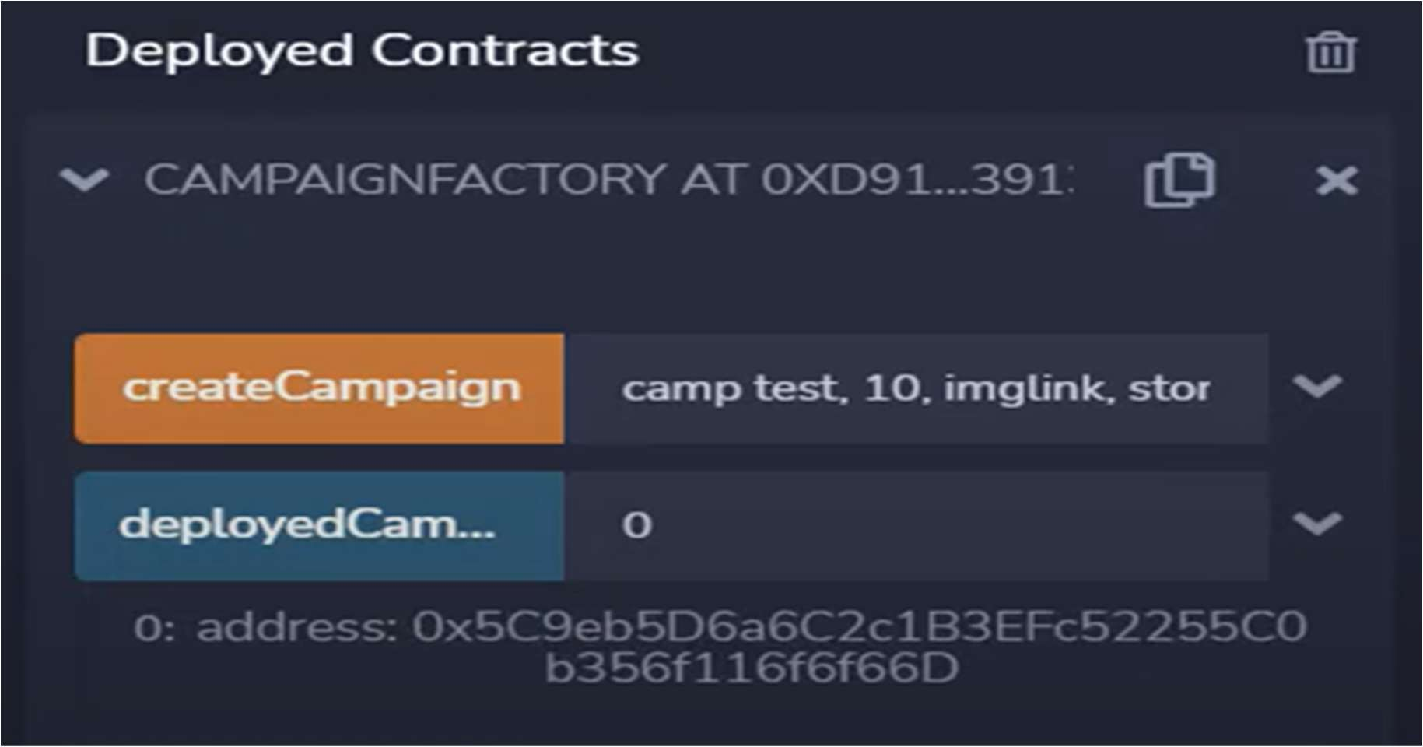

**Figure 19**

* + 1. **Results**

The integration of disaster response and recovery technologies with blockchain will make the recorded data accessible to all parties involved in the blockchain network. Transparency will be provided throughout the system and network by combining external data sources or databases onto a single platform. Every request and response made during the crisis was able to be handled promptly and without any misunderstanding among the network's participants. The blockchain network authenticates itself as a trustworthy solution by verifying and ensuring that every information sent over it is free from tampering. Due to the legitimate processing by the certificate authority in the blockchain network, all users in the network are verified and there are no duplicate users. No further connectivity will be allowed if any user is found to be acting deliberately, and they will be isolated from the 1642 XVII AIMS

International Conference on Management network. The blockchain network's consensus mechanism will be able to identify the malicious node, which will prevent any information from coming from that particular node from being broadcast. Blockchain uses its cryptographic hash function to preserve the privacy of user information. As a result, there is no concern about bias or threatening while validating the information in the network. This will increase the veracity of the information, enabling timely decision-making. Information can be protected and tamper-free with blockchain. In a dynamic environment, there is a need to process needs and offer resources as quickly as possible. With blockchain, all peers are connected to a single network, allowing the Information technologies and disaster management blockchain to validate any request. As a result, every request receives a prompt answer. This will make it possible to quickly transfer commodities and money amongst parties that are involved. It is not practically possible to change the hash value of every block up until the genesis block if any changes to any information cause the transaction's hash value to change. Information transferred to blockchain is therefore highly secure.

**Following are some comparative results:**

* We can fetch the data faster from the server i.e. Server side loading is faster.
* Improved the latency of the transactions.
* Computational load is comparatively less

### Comparative Analysis

These Functionalities of concerned websites has been obtained by Page Speed Insights:

|  |  |  |  |
| --- | --- | --- | --- |
| **S.No.** | **Functionality** | **Traditional Implemented Project**  **(in Percentage)** | **Our Implemented** |

|  |  |  |  |
| --- | --- | --- | --- |
|  |  |  | **Project(in Percentage)** |
| 1. | Performance | 6 | 73 |
| 2. | Accessibility | 87 | 94 |
| 3. | Best Practice | 75 | 83 |
| 4. | SEO (Search engine optimization) | 83 | 73 |

**Table 2- Comparison table**

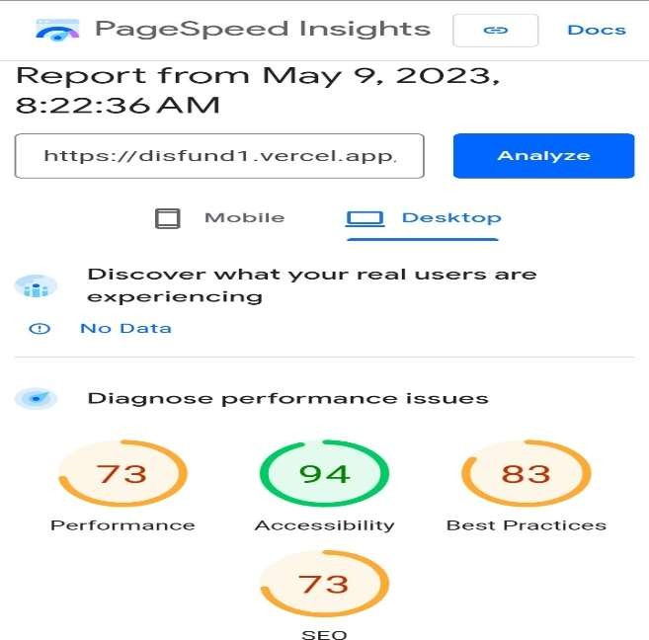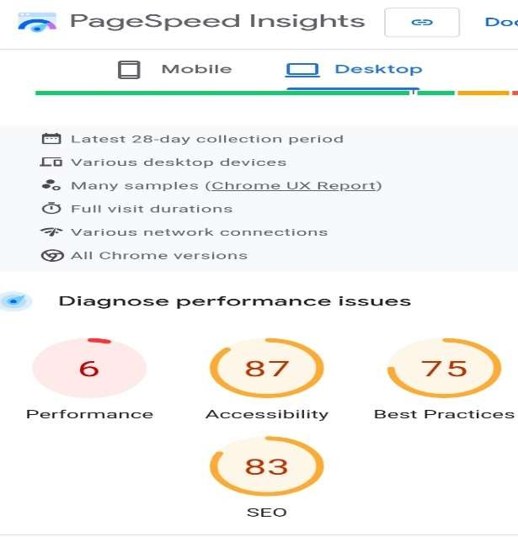

Fig 4. Traditional Website Functionalities Fig 5. Our Website Functionalities

**Our implemented website has Speed Index of 0.9s whereas traditional government website has Speed Index of 4.4s**

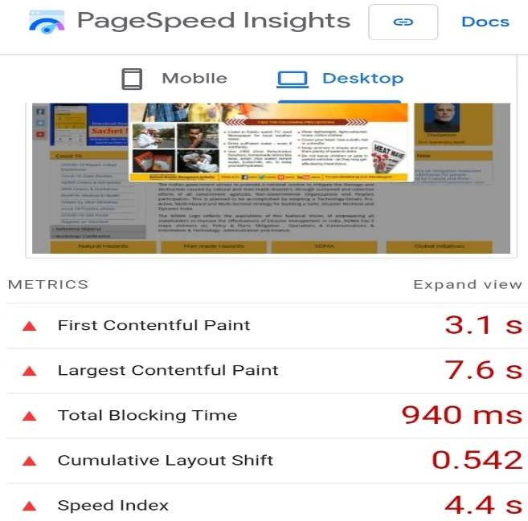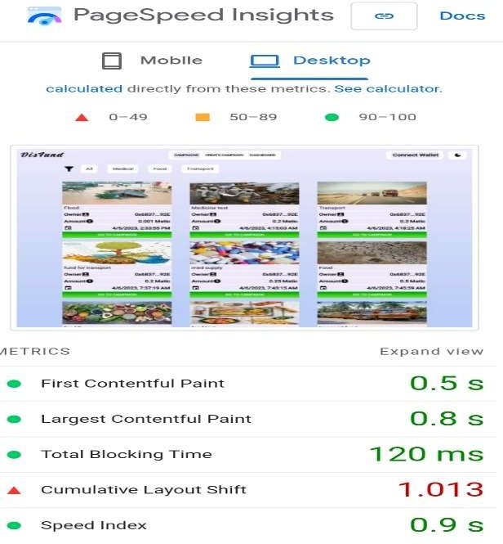

Fig 6. Our Implemented website Speed Fig 7. Traditional Website Speed

# CHAPTER 5

## CONCLUSION AND FUTURE WORK

### Conclusion

Being prepared for emergencies is impossible since they are unpredictable. In a dynamic environment, there is a need to process needs and offer resources as quickly as possible. With blockchain, all peers are connected to a single network, allowing the Information technologies and disaster management blockchain to validate any request. As a result, every request receives a prompt answer. This will make it possible to quickly transfer commodities and money amongst parties that are involved. All financial transactions that occur will also be documented and accessible at any moment for additional review.

By leveraging blockchain technology, stakeholders involved in disaster management can streamline coordination and collaboration, ensuring seamless communication and information exchange between various organizations, including government agencies, non- profit organizations, and volunteers. The use of smart contracts enables automated execution of predefined rules, ensuring timely delivery of resources and services to affected areas. Furthermore, blockchain's transparent and tamper-proof nature enhances accountability and trust among stakeholders, minimizing the risk of fraud and corruption.

### Future Work:

While this project has provided valuable insights into the potential of blockchain in disaster management, there are several areas that require further exploration and development. Future work in this field can focus on the following aspects:

Scalability: Blockchain technology still faces challenges related to scalability and transaction throughput. Future research can investigate techniques such as sharding, off-chain transactions, and layer-two solutions to improve the scalability of blockchain networks in disaster management scenarios.

Interoperability: Disaster management involves multiple stakeholders who may be using different blockchain platforms or traditional centralized systems. Future work can focus on developing interoperability standards and protocols to enable seamless data exchange and collaboration between various systems.

Privacy and Security: While blockchain offers transparency, privacy concerns may arise in certain disaster management situations where sensitive information needs to be protected. Future research can explore privacy-enhancing techniques such as zero-knowledge proofs and secure multiparty computation to address these concerns.

User-Friendly Interfaces: To encourage widespread adoption of blockchain technology in disaster management, user-friendly interfaces and intuitive applications need to be developed. Future work can focus on designing user-centric interfaces that simplify the interaction with blockchain-based systems and cater to the specific needs of different stakeholders.

Real-World Implementation and Evaluation: Further research can involve real-world pilot projects and case studies to evaluate the practicality, effectiveness, and cost-efficiency of implementing blockchain technology in disaster management. These implementations can provide valuable insights and feedback to refine existing solutions and identify new challenges.

By addressing these areas, future research and development can contribute to the maturation and widespread adoption of blockchain technology in disaster management, ultimately leading to more efficient and resilient emergency response systems.

In conclusion, the implementation of blockchain technology in disaster management has shown great potential in enhancing the efficiency, transparency, and reliability of various processes involved in emergency response and recovery efforts. Through the use of decentralized and immutable ledgers, blockchain offers several benefits such as secure data sharing, smart contract automation, and decentralized decision-making. This project has explored and highlighted the key applications of blockchain in disaster management, including supply chain management, resource allocation, identity verification, and financial transactions.

## REFRENCES

1. Seebacher, S., & Sch, R. (2017). Blockchain Technology as an Enabler of Service Systems : A Structured Literature Review, 12–23. https://doi.org/10.1007/978-3-319- 56925- 3
2. Kamble, S., Gunasekaran, A., & Arha, H. (2018). Understanding the Blockchain technologyadoption in supply chains Indian context. International Journal of Production Research, 0(0), 1–25. https://doi.org/10.1080/00207543.2018.1518610
3. Wang, H., Chen, K., & Xu, D. (2016). A maturity model for blockchain adoption. Financial Innovation. https://doi.org/10.1186/s40854-016- 0031-z
4. Sujit Biswas, Kashif Shaif, Boubakr Nour, Yu Wang and Fan Li. Scalable Blockchain Framework for Secure Transactions in IoT. In IEEE Internet of Things Journal, October 2018
5. Vinayak G. Bhat, H. P. Pranaav, S. Mini, Deepak Tosh. Blockchain-centric Resource Management System for Disaster Response and Relief.
6. G.V. Sobha, P. Sridevi. Usecase of Blockchain in Disaster Management- A Conceptual View. Seventeenth AIMS International Conference on Management.
7. Zyskind, G., & Pentland, A. S. (2015). Decentralizing Privacy : Using Blockchain to Protect Personal Data. https://doi.org/10.1109/SPW.2015.27
8. Sakurai, M., & Murayama, Y. (2019). – Benefits and issues. Progress in Disaster Science, 2, 100012. https://doi.org/10.1016/j.pdisas.2019.100012
9. Shrier, D., Wu, W., & Pentland, A. (2016). Blockchain & Infrastructure (Identity, Data Security). MIT Connection Science, (3), 18. https://doi.org/10.1029/2005wr004336
10. Svein, Ø. (2016). Beyond Bitcoin Enabling Smart Government Using Blockchain Technology, 253–264. https://doi.org/10.1007/978-3-319-44421-5

## Plagiarism Report Status

**Details of Report in terms of Plagiarism and Uniqueness in Percentage**

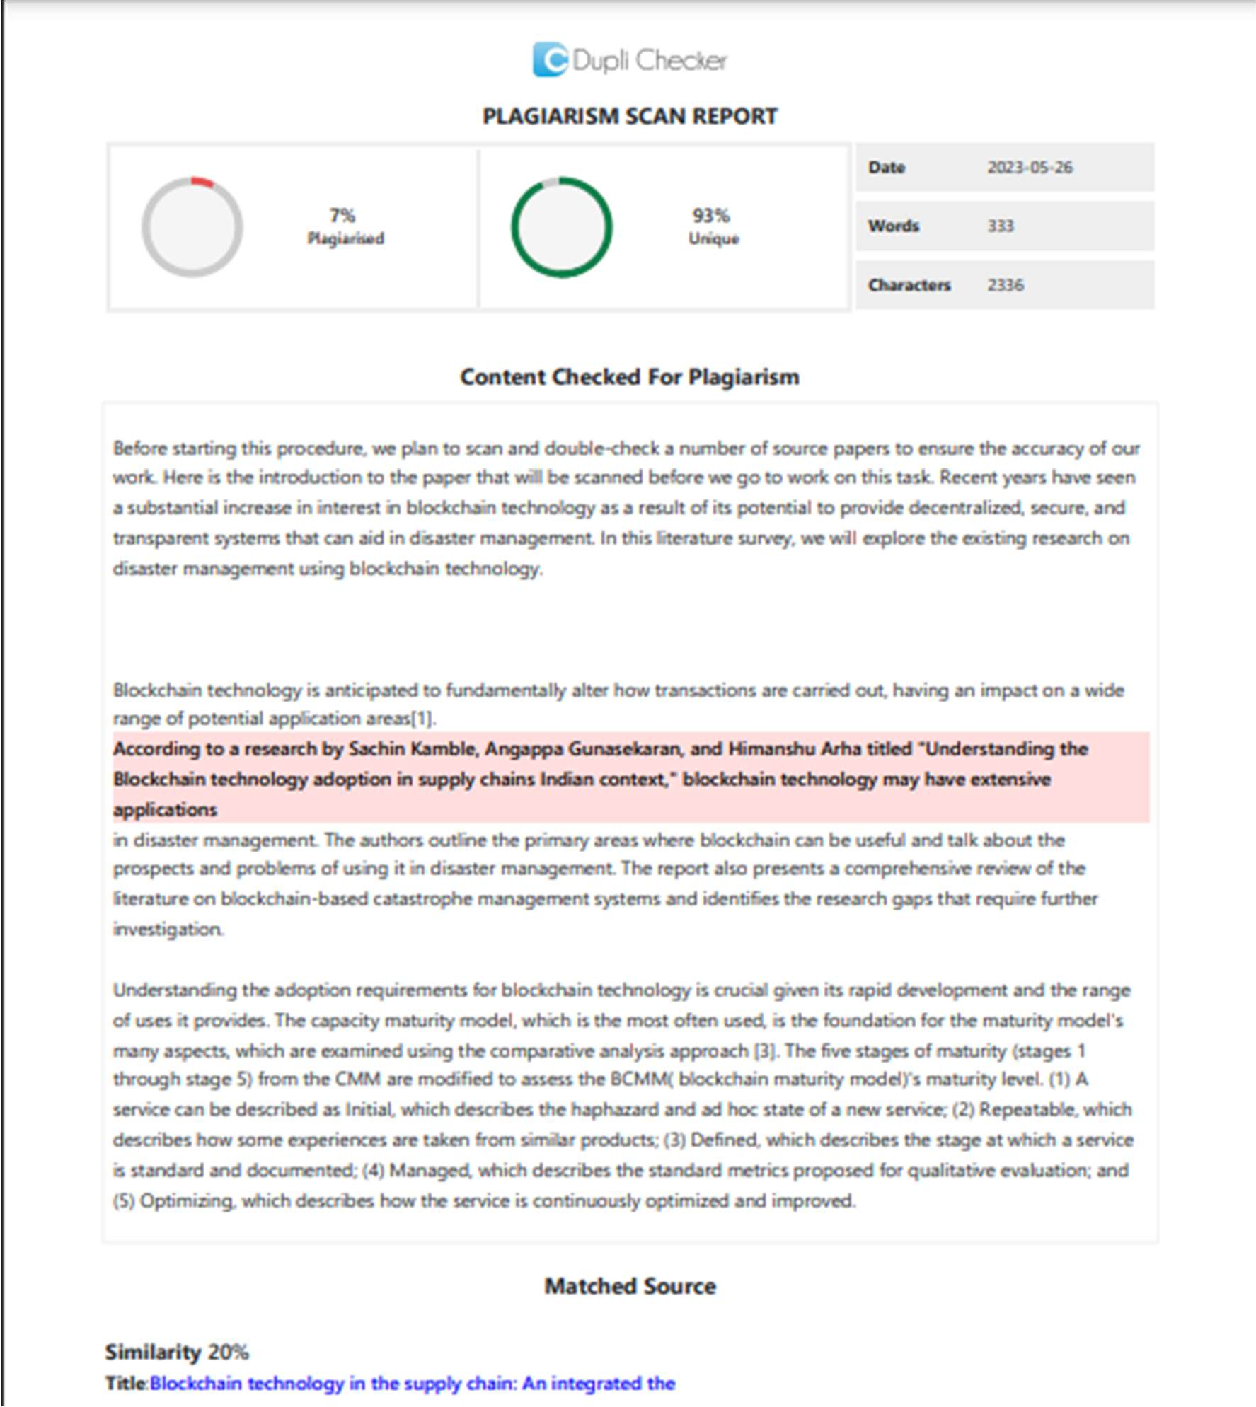

## RESEARCH PAPER

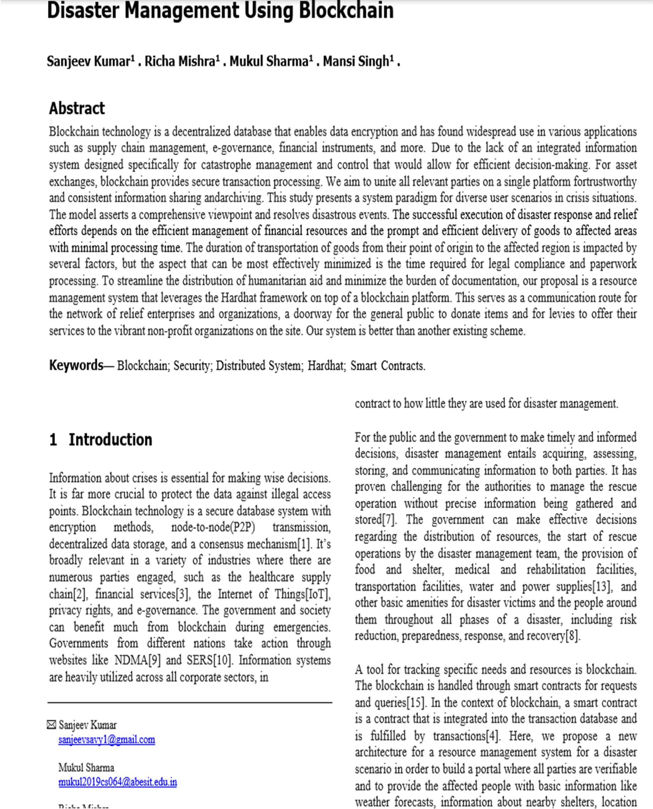

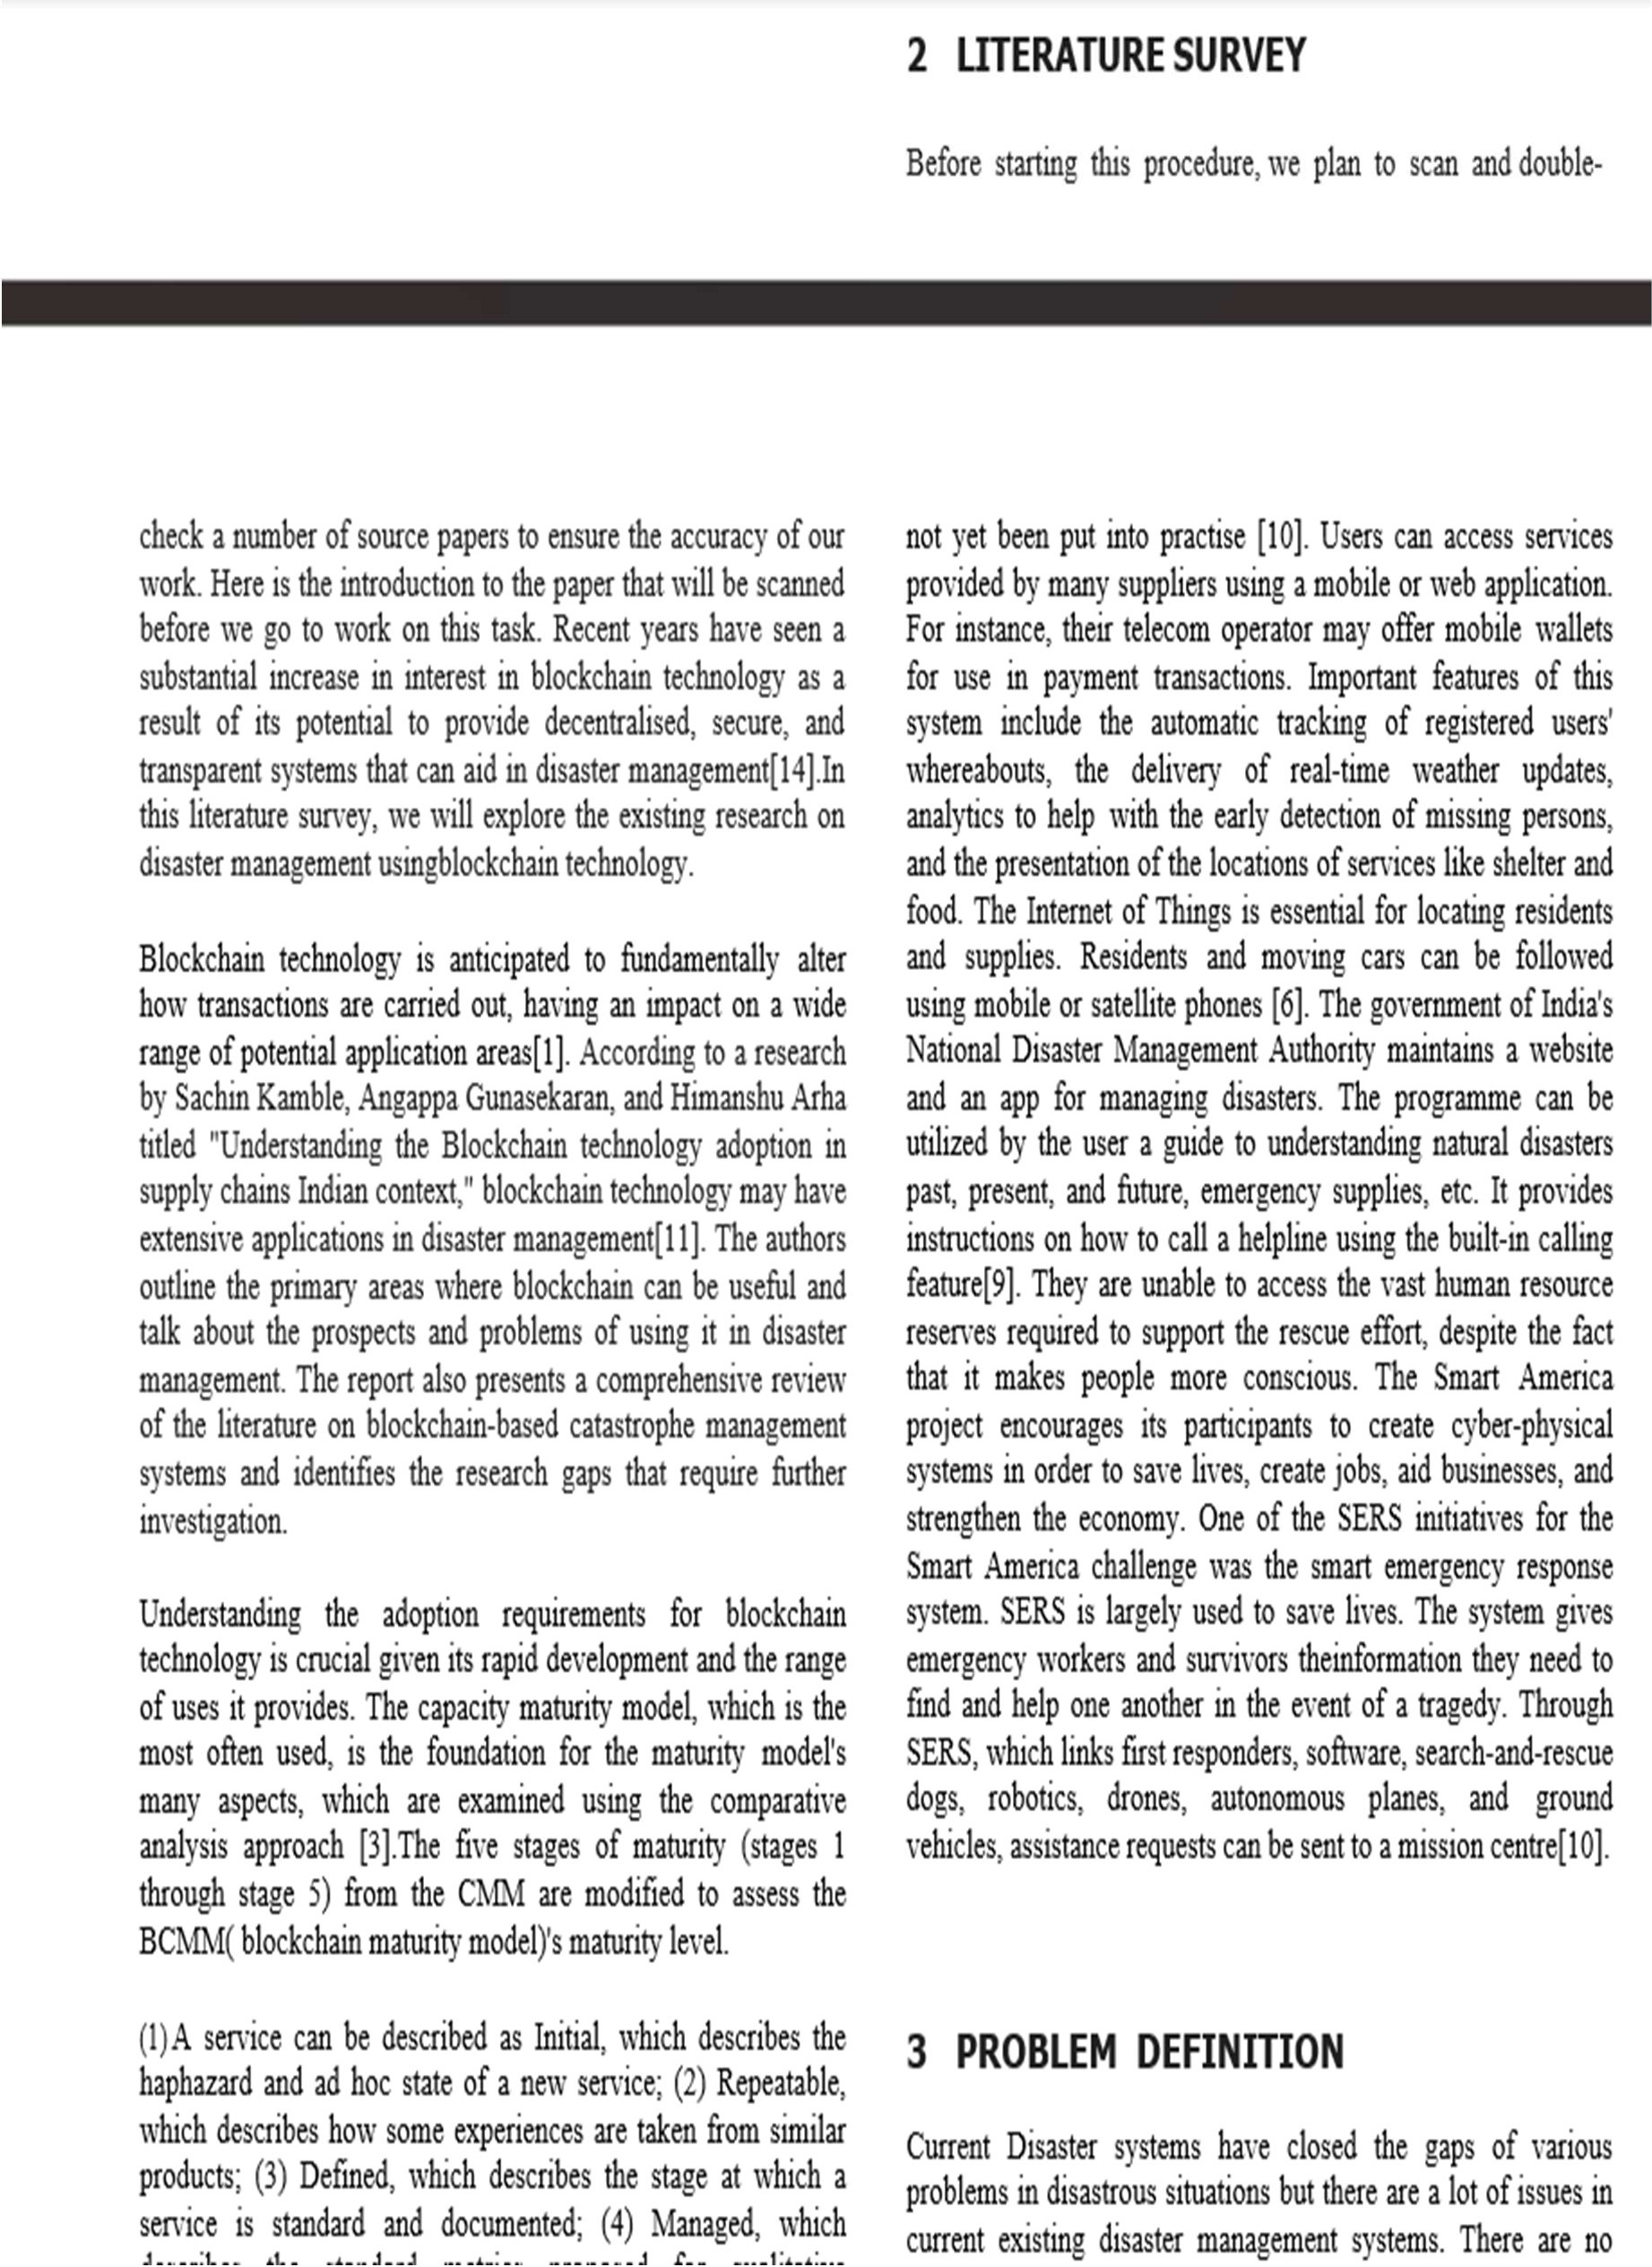

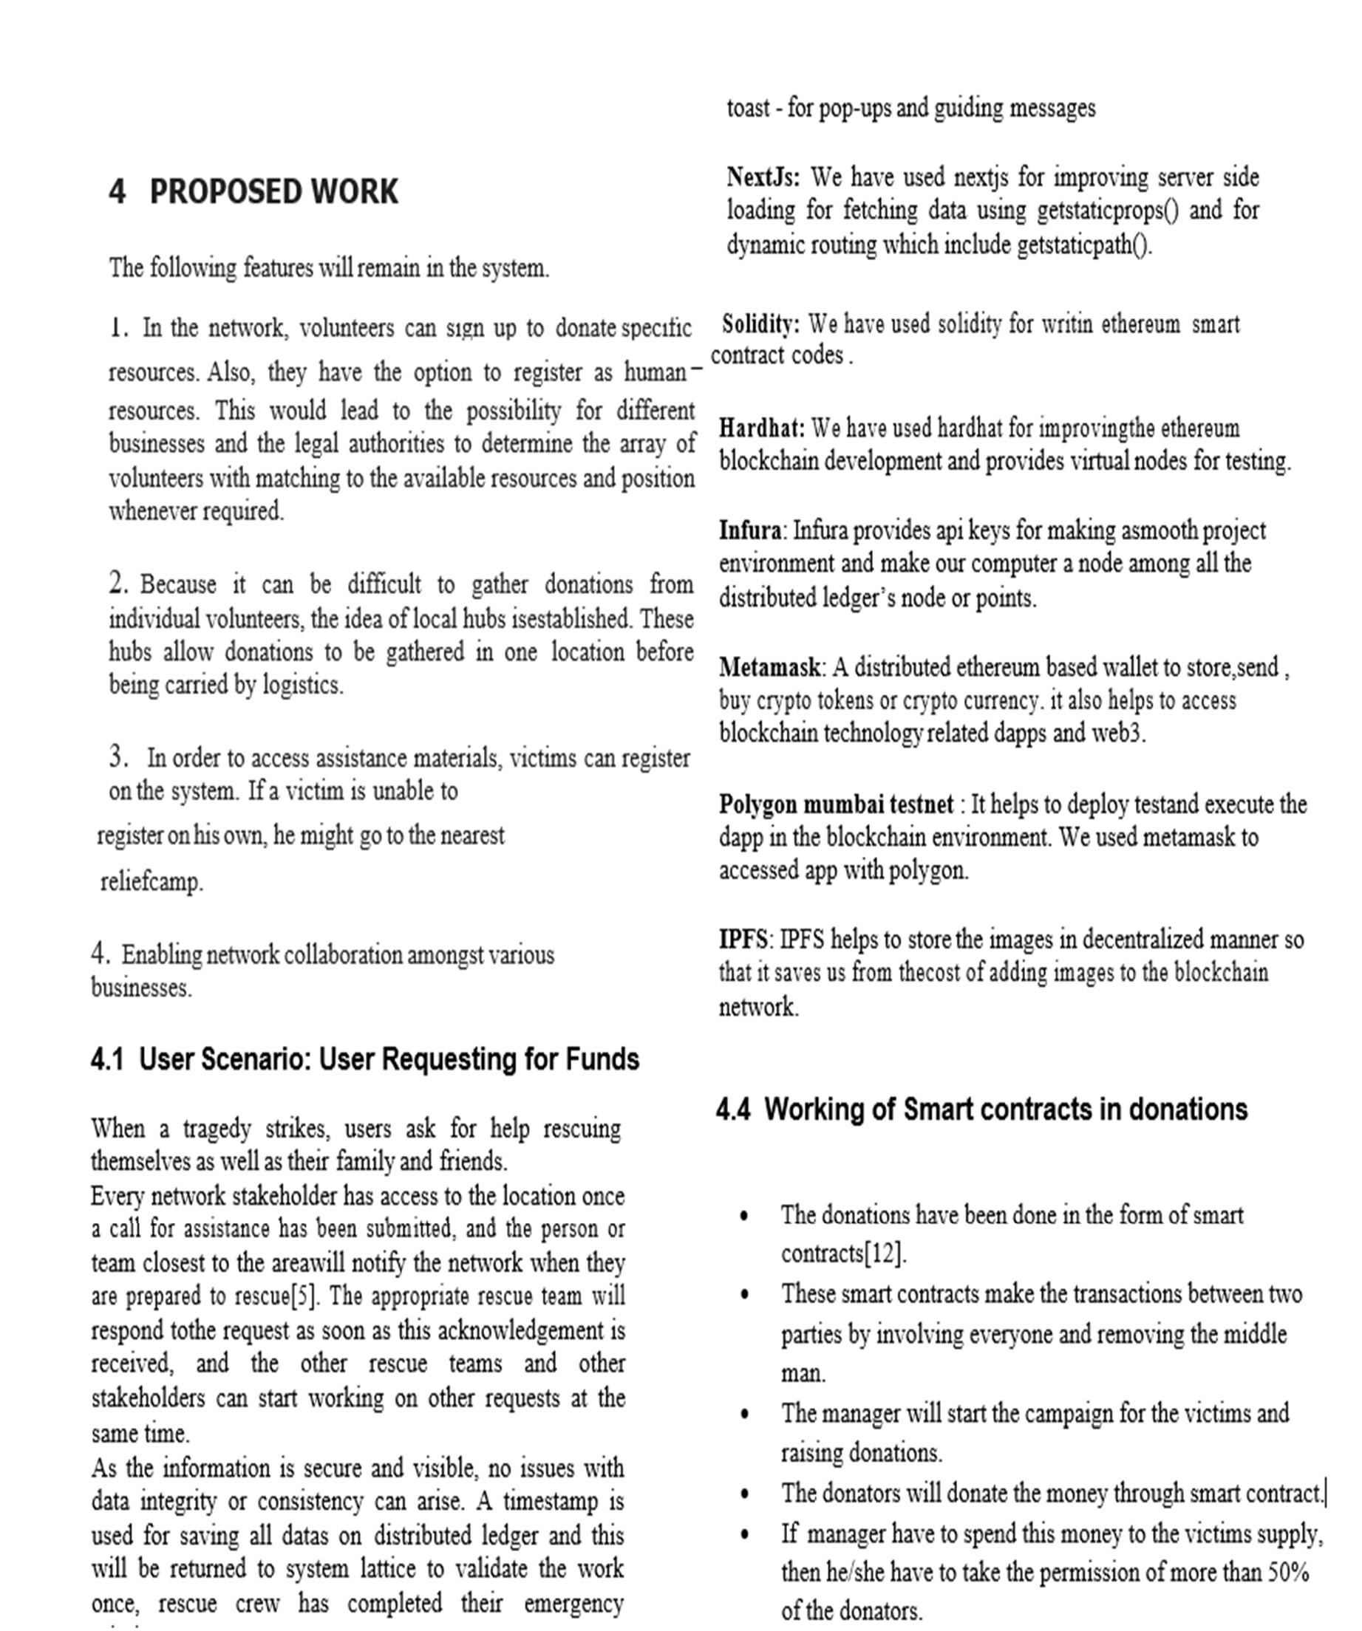

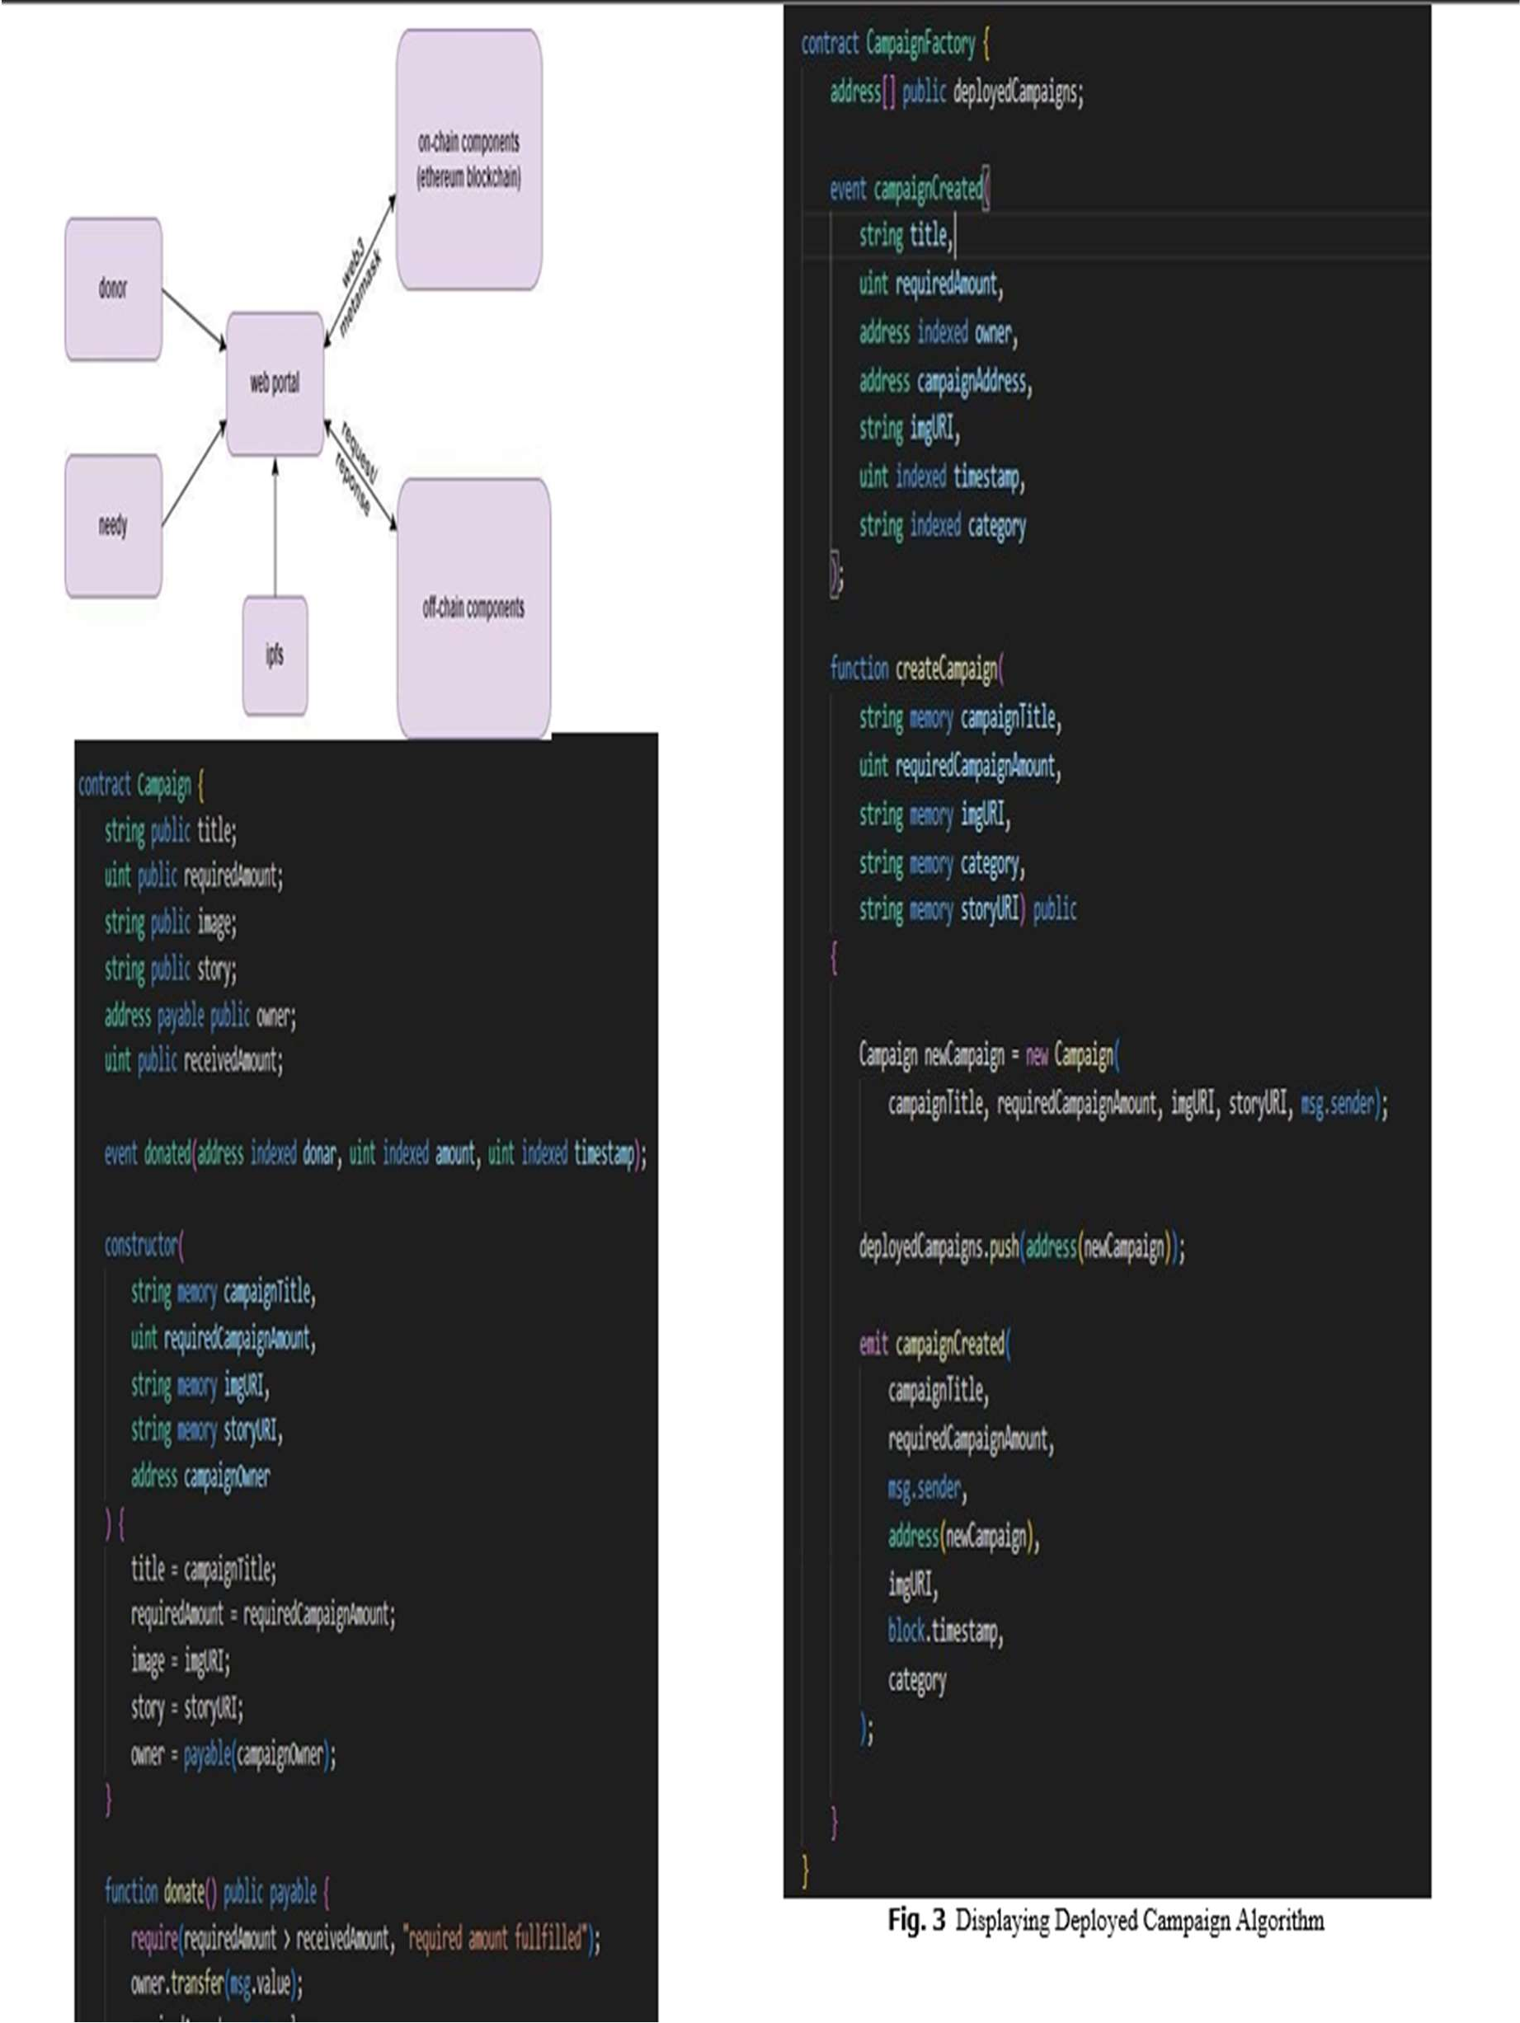

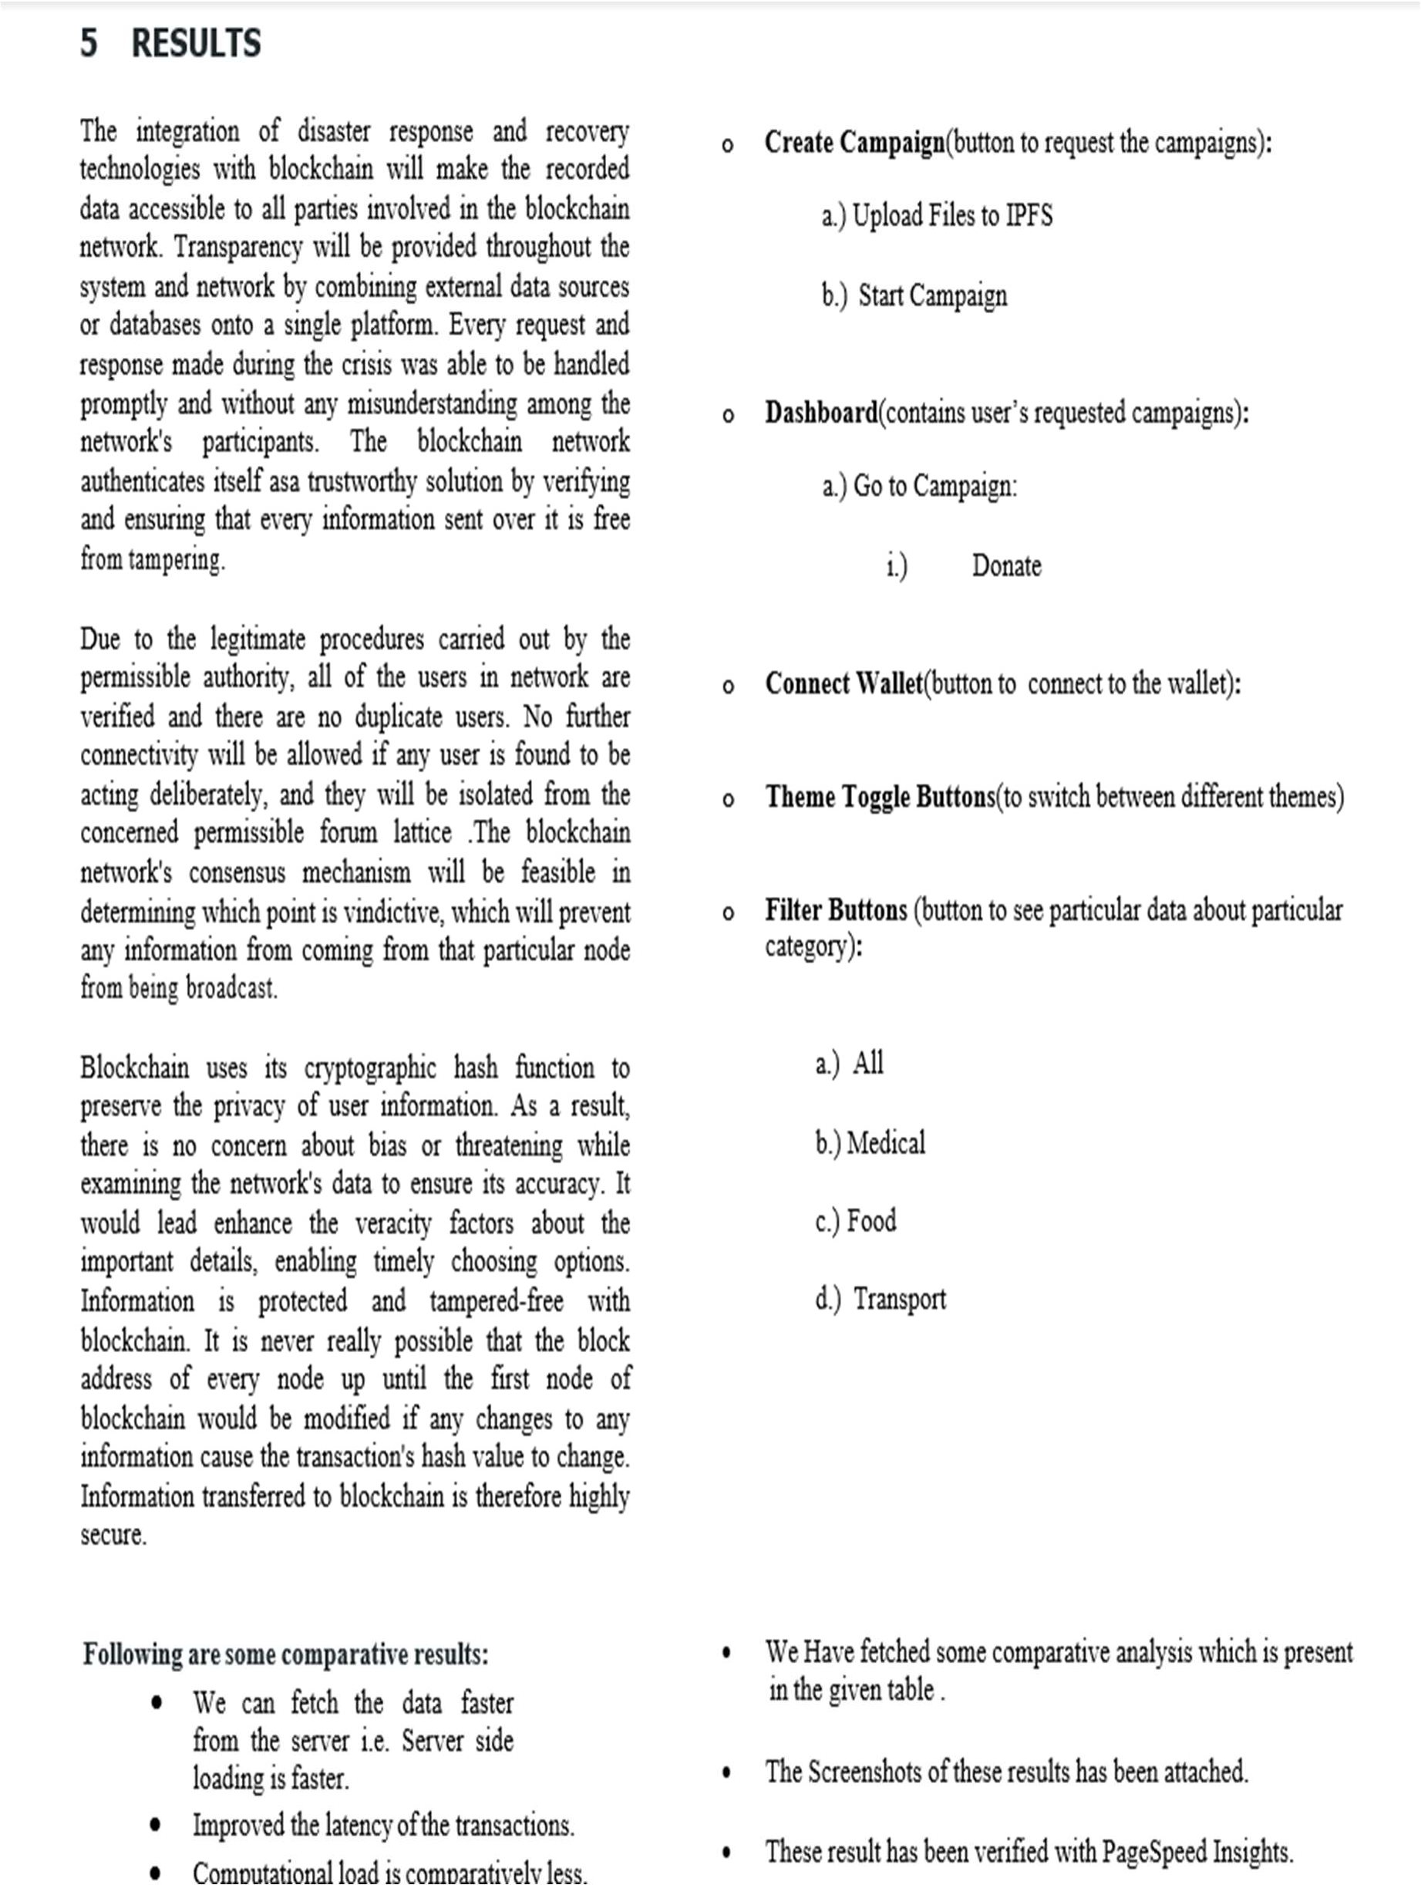

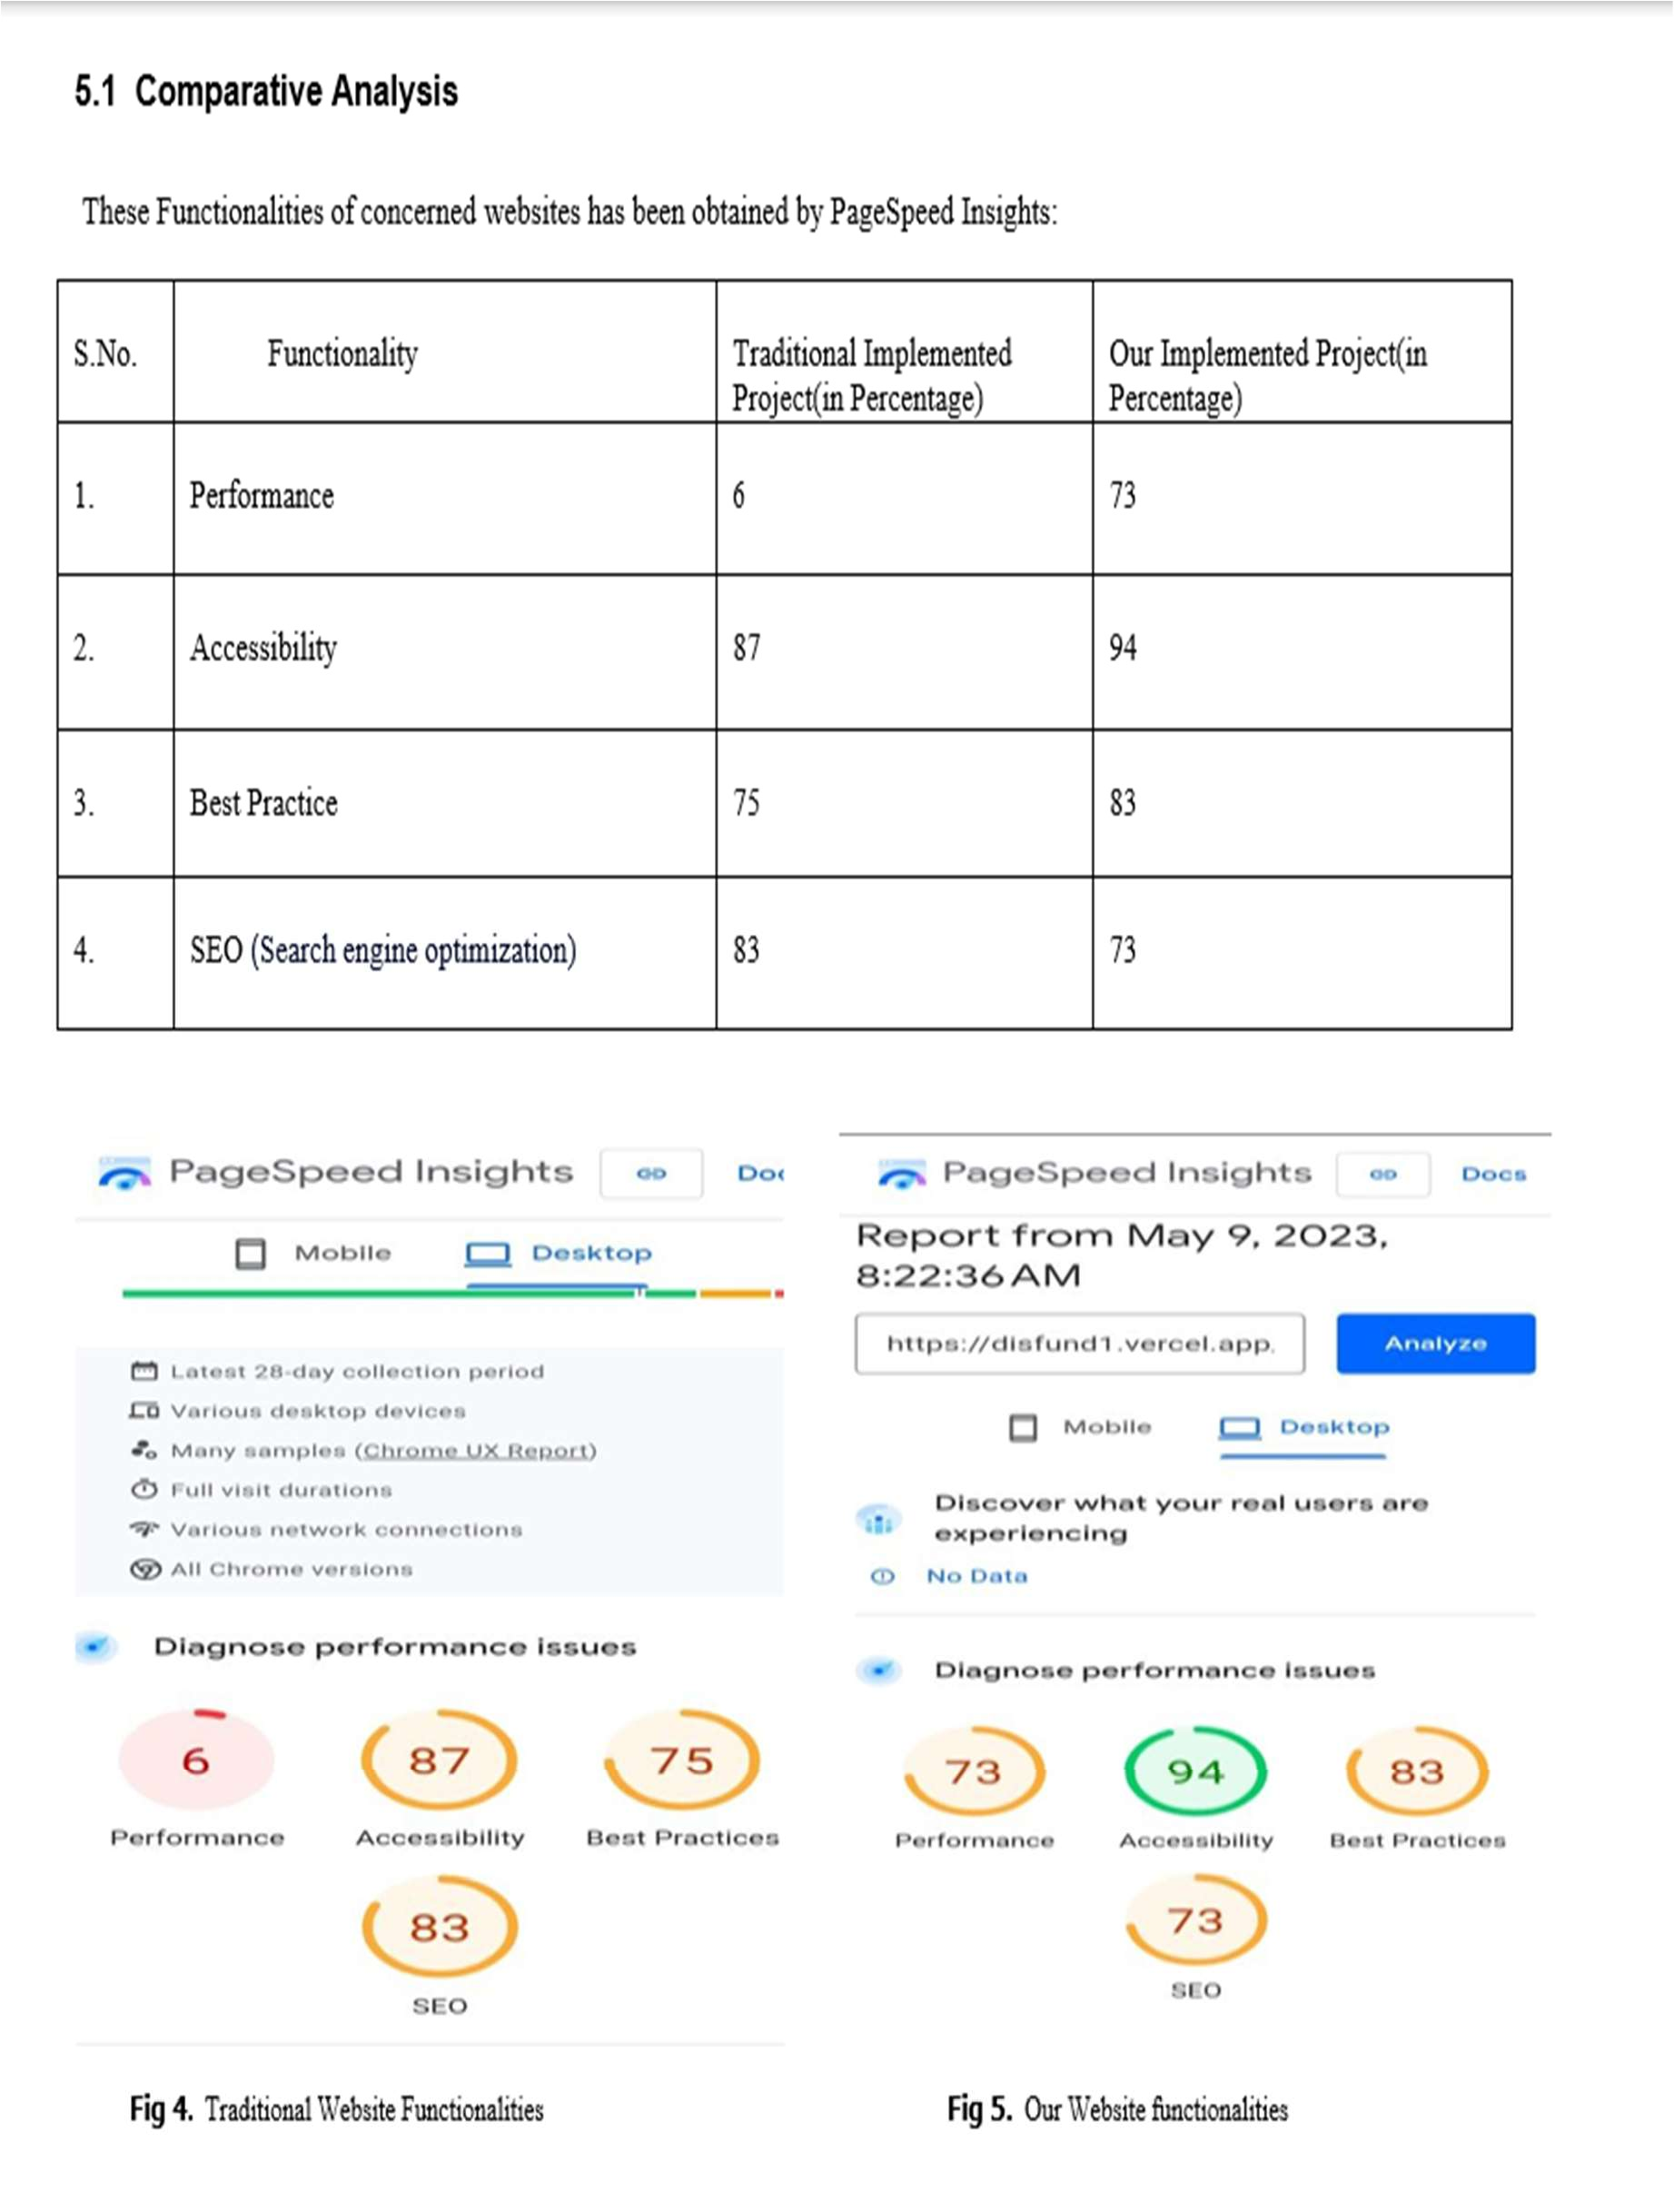

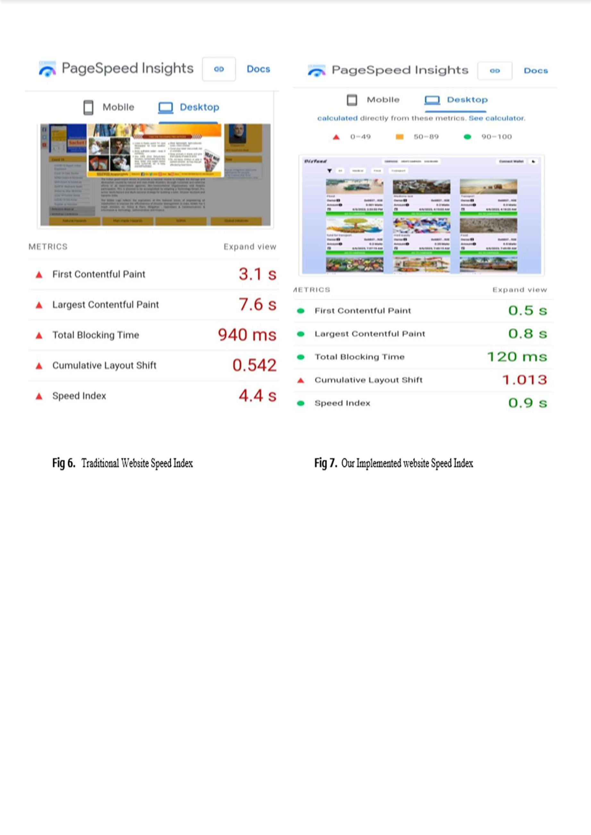

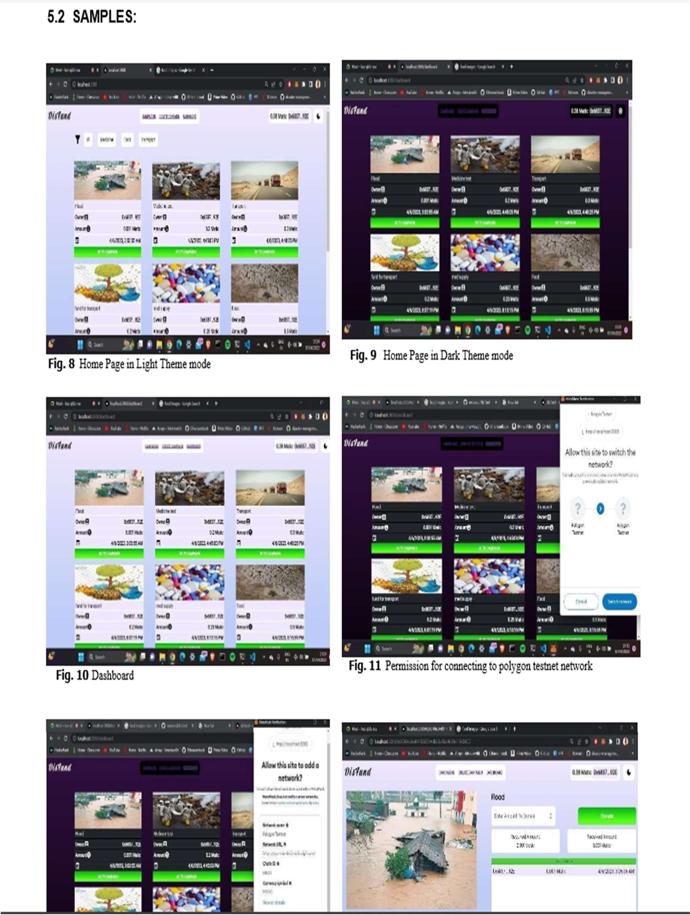

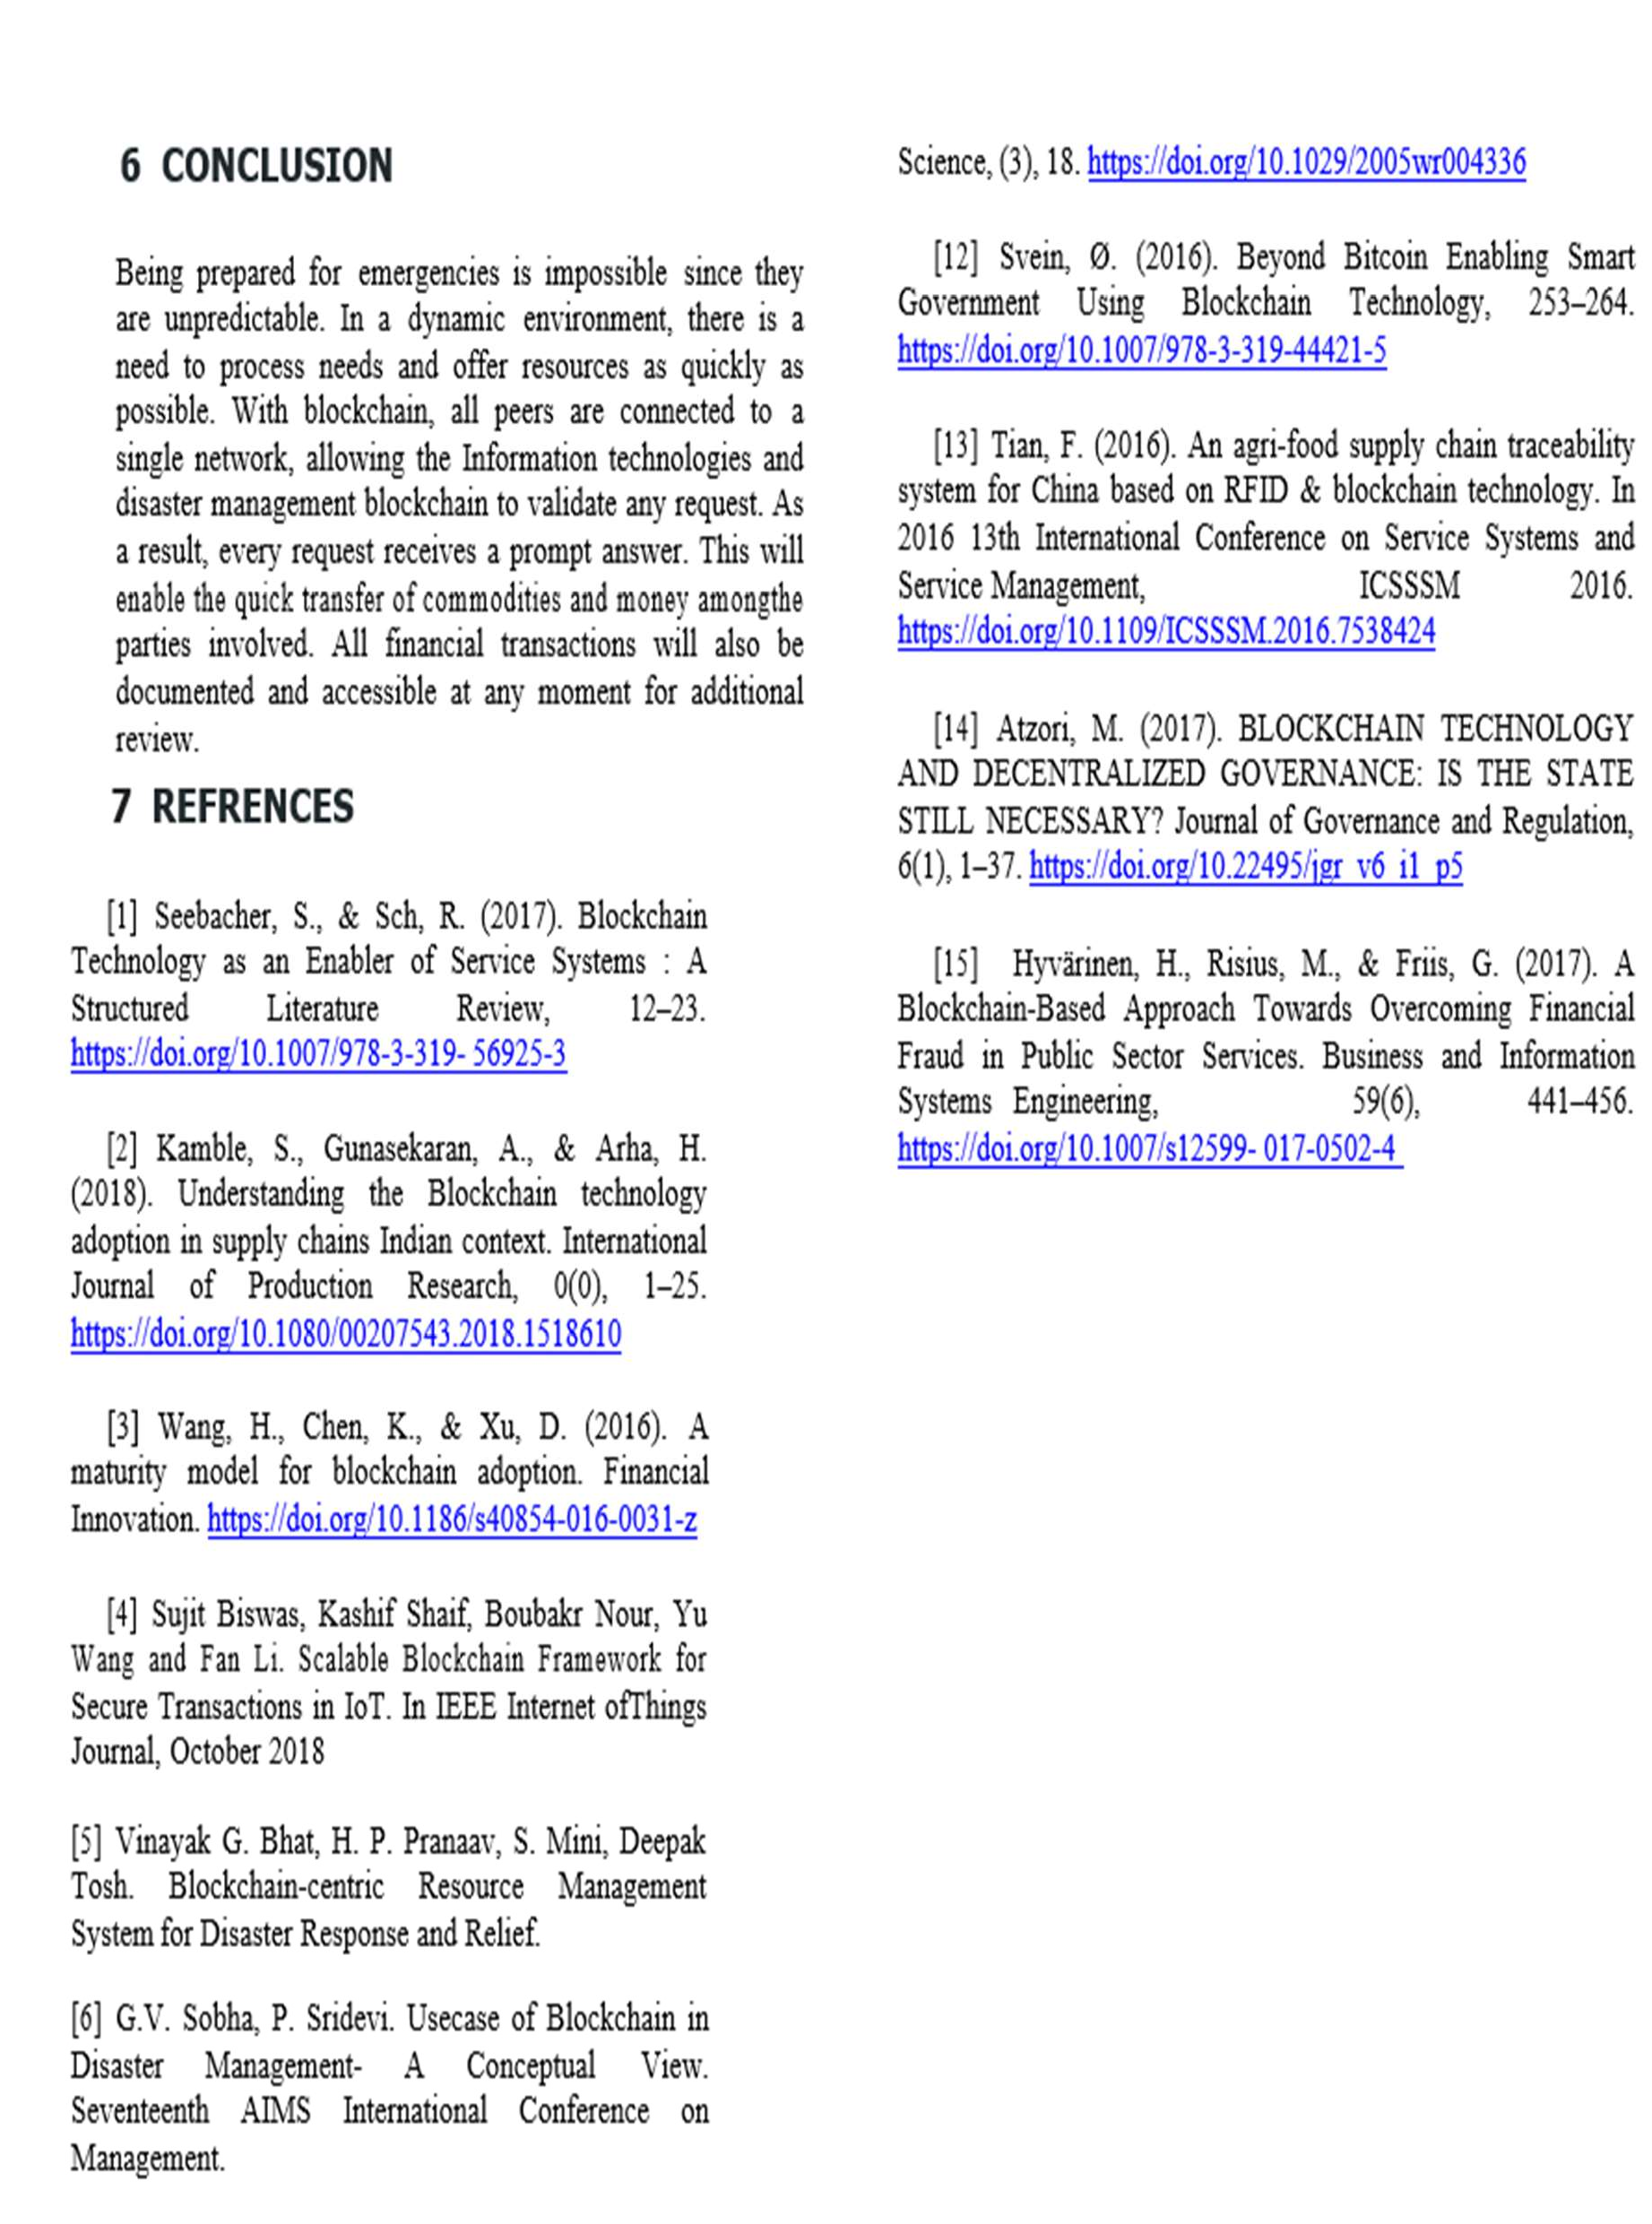

**RESEARCH PAPER PUBLICATION DETAIL**

Applied in International Journal of Blockchain and Cryptocurrencies Inderscience (google scholar indexed)